Management Control System

Software Training Materials

Contents

1. INTRODUCTION OF MANAGEMENT CONTROL SYSTEM 4

How to Log in the MCS 5

2. Planning and Development Wing 6

3. Planning and Development Dashboard 6

4. Planning and Development Menus Overview 9

4.1: Feasibility Study(Menu) Overview 10

4.1.1: Create ( Feasibility Study) Add New Feasibility Study Input Form 10

4.1.2: Manage (Feasibility Study ) View of Feasibility Study Data 11

4.1.2.1: Manage (Feasibility Study) View of single Feasibility Study Report 12

4.1.2.2: Manage (Feasibility Study) Print functionality 12

4.1.2.3: Manage (Feasibility Study ) Update Feasibility Study functionality 13

4.2: On Going Projects Overview 14

4.2.1:Create(On Going Project) Add new Construction Input Form 14

4.2.2: Manage (On Going Project) View of Construction Details 15

4.2.2.1: Manage (On Going Project) Add More Details 15

4.2.2.2: Manage (On Going Project) View of Monthly (All) Project Report 16

4.2.2.3: Manage (On Going Project) View of Monthly (Single) Project Report 16

4.2.2.4: Manage (On Going Project) Delete Monthly (Single) Project Report 17

4.2.2.5: Manage (On Going Project) Upload Monthly Project Report 17

4.2.2.6: Manage (On Going Project) Update & Delete Construction functionality 18

4.3: Pipeline Overview 19

4.3.1: Create (Pipeline) Add New Pipeline Input Form 19

4.3.2: Manage (Pipeline) View of Pipeline Data 20

4.3.2.1: Manage (Pipeline) Edit functionality 20

4.3.2.2: Manage (Pipeline) Delete functionality 20

4.4: Project Progress Overview 21

4.4.1: Create (Project Progress) Add Construction of new projects & Add Details of project progress Input Form 22

4.4.2: Manage (Project Progress) View Of Project Data 22

4.4.2.1: Manage (Project Progress) View Of Construction Details 23

4.4.2.2: Manage (Project Progress) Print functionality 23

4.4.2.3: Manage (Project Progress) Edit functionality 24

4.4.3: Photo Gallery (Project Progress) View Of Photo Gallery Data 26

4.4.3.3: Photo Gallery (Project Progress) Edit Gallery Data 27

4.5: O & M (Operations And Maintenance) Overview 29

4.5.1: Create (O & M) Add New Operations & Maintenance Input Form 29

4.5.2: Manage (O & M) View of Operations & Maintenance Data 30

4.5.2.1: Manage (O & M) Update Operations & Maintenance Data 30

4.6: PPP Cell Overview 31

4.6.1: About PPP Cell(PPP Cell) View of about ppp cell 31

4.6.2.1: Create-Upcoming ppp project-(PPP Cell) Upcoming ppp project create input from 33

4.6.2.2: Manage-Upcoming ppp project-(PPP Cell) View of upcoming ppp project data 34

4.6.3.1: Create-Ongoing ppp project-(PPP Cell) Ongoing ppp project create input from 36

4.6.3.2: Manage-Ongoing ppp project-(PPP Cell) View of ongoing ppp project data 37

4.6.3.2.1: Manage-Ongoing ppp project-(PPP Cell) Search 37

4.6.3.2.2: Manage-Ongoing ppp project-(PPP Cell) Update ongoing project 37

4.6.3.2.3: Manage-Ongoing ppp project-(PPP Cell) Delete 38

4.7: FAQ Overview 39

4.7.1: Create (FAQ) View of faq data 39

4.7.2: Create (FAQ) Add Data input form 39

4.7.3: Create (FAQ) Edit 40

4.7.4: Create (FAQ) Delete 40

4.8: Settings Overview 41

4.8.1.1: FCP(Settings) View of fcp data 42

4.8.1.2: FCP(Settings) Add data input form 42

4.8.1.3: FCP(Settings) View of fcp single data 42

4.8.1.4: FCP(Settings) View of fcp single data edit 43

4.8.1.5: FCP(Settings) View of fcp single data delete 43

4.8.2.1: Component Data(Settings) Add data input form 44

4.8.2.2: Component Data(Settings) View of component and project data 45

4.8.2.3: Component Data(Settings) component data edit 46

4.8.2.5: Component Data(Settings) Project data edit 47

4.8.2.6: Component Data(Settings) Project data delete 47

4.8.3.1: Project Data(Settings) Add project data input form 48

4.8.3.2: Project Data(Settings) project data edit 49

4.8.3.3: Project Data(Settings) project data delete 49

# 

# 1. INTRODUCTION OF MANAGEMENT CONTROL SYSTEM

……….

….

…….

…….

…….

The link for MCS is <http://192.168.3.7:3000/> which is accessible within BBA’s local network . After search will open a login page. Which is like –

## How to Log in the MCS

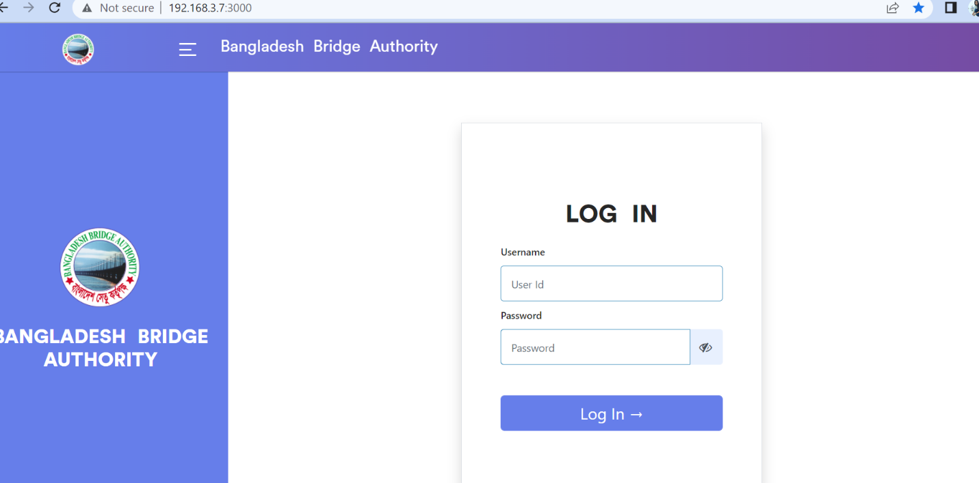

Figure 1: Log in Page

**Steps to Log in MCS**

1. User will input his Username
2. User will input his Password
3. Click Log In Button

If the username & password are correct, users will get access into the system.

# 2. Planning and Development Wing

For Planning and development module –

**Steps to Enter in Planning And Development**

1. After login will show this dashboard of MCS.

2. Click on Planning and Development.

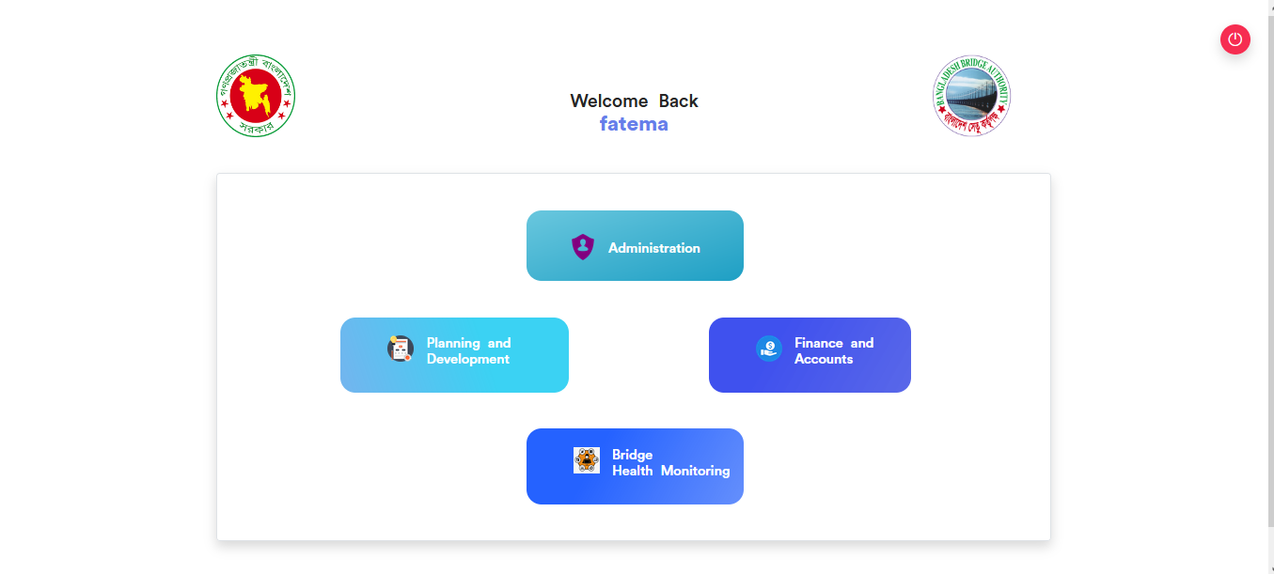

Figure 2: Dashboard of MCS

# 3. Planning and Development Dashboard

After clicking into Planning And Development then it will redirect to (P&D) dashboard with some menus.

There are three segments on the right side of the P & D Dashboard Such as **Feasibility Study** ,**On Going Projects** and **Operations and Maintenance**.

**Feasibility Study**: To generate various report from the feasibility study just do the following step .

1.Click on the relevant link ( Inspection ,Lap Rap, Draft ,Interim ,Final) report to generate the relative report.

**On-Going project :** To see the Monthly Project Reporting data click on it.

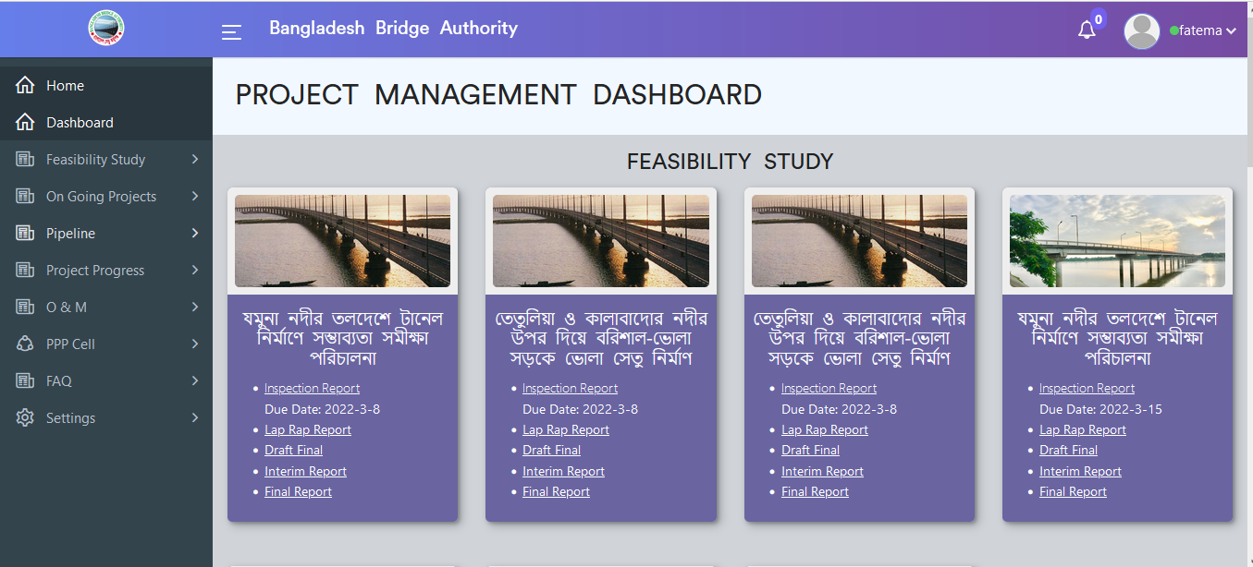

Figure 3.1: Dashboard of P&D (feasibility study)

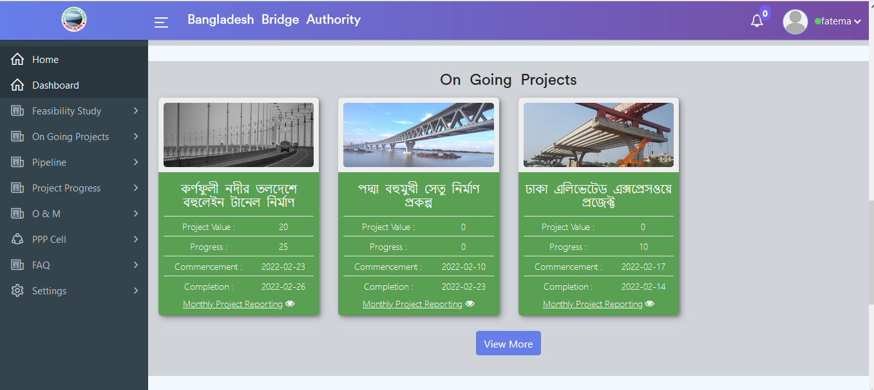

Figure 3.2: Dashboard of P&D (On Going Projects)

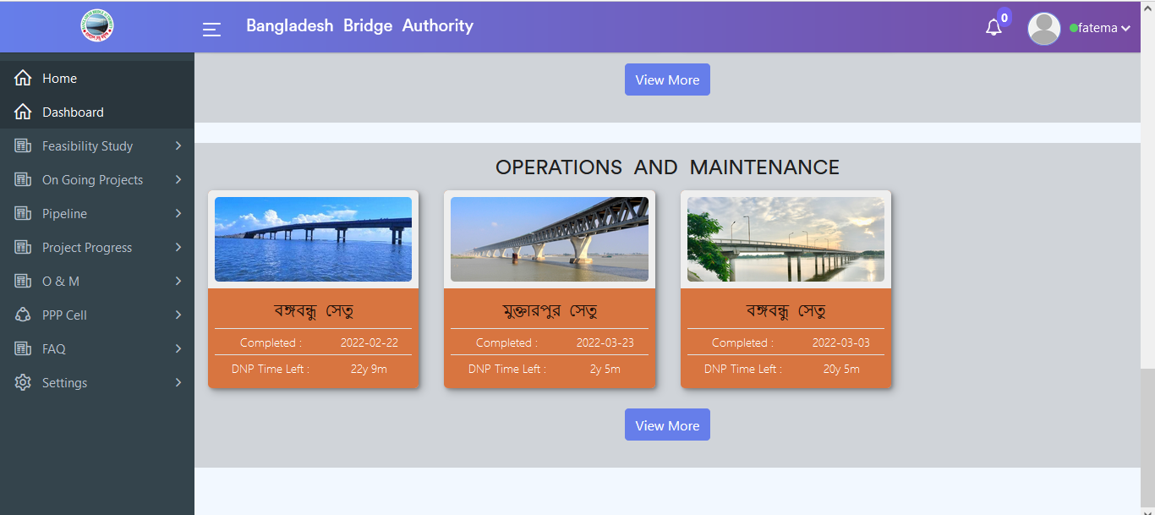

Figure 3.3: Dashboard of P&D (Operation & maintenance)

# Planning and Development Menus Overview

## 4.1: Feasibility Study(Menu) Overview

**Overview of Feasibility Study**

Click on the Feasibility Study after that there will appear two sub-menus and they are Create and Manage Feasibility Study .

### 4.1.1: Create ( Feasibility Study) Add New Feasibility Study Input Form

Click on the Create sub menu after that add new feasibility input form will appear as like below scenario . User must fill up the required input fields with appropriate values to store feasibility data in the database.

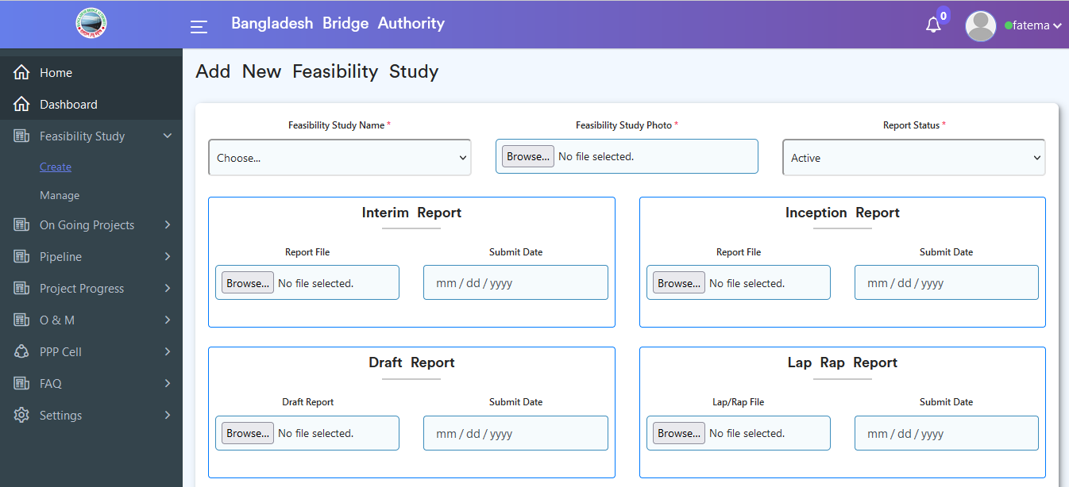

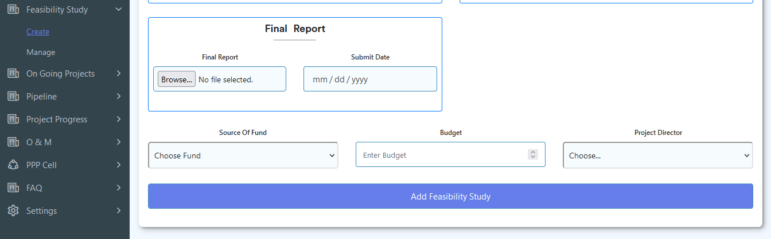

Figure 4.1.1: Create (feasibility Study) add new feasibility input form

### 4.1.2: Manage (Feasibility Study ) View of Feasibility Study Data

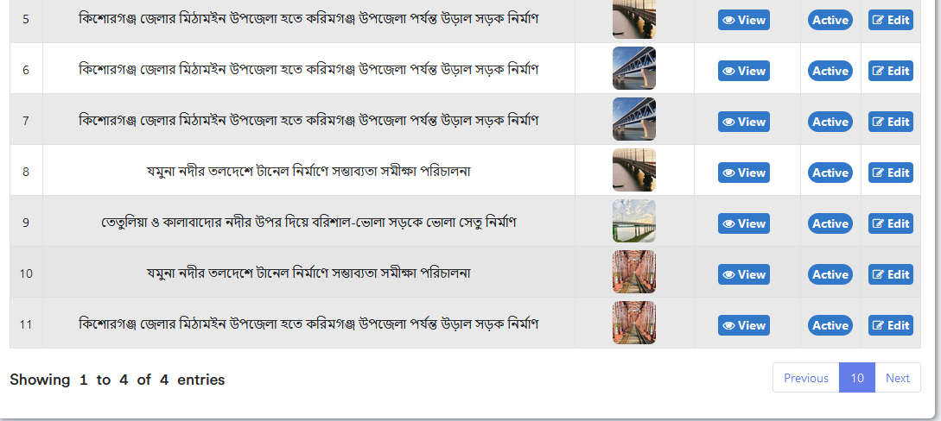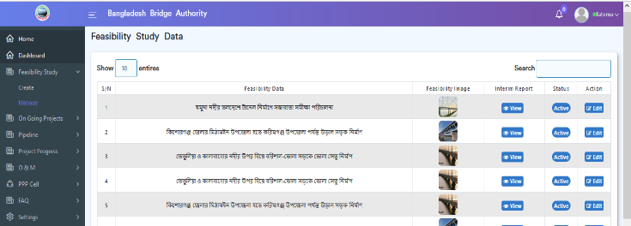Click on the Manage sub-menu from the feasibility Study sidebar menu after that looks like the below feasibility study data will appear if data is available in the database .

Figure 4.1.2: Manage (feasibility study ) view of feasibility study data

### 4.1.2.1: Manage (Feasibility Study) View of single Feasibility Study Report

In the Manage (feasibility study) data table if click on the view button then will show look like the below scenario.

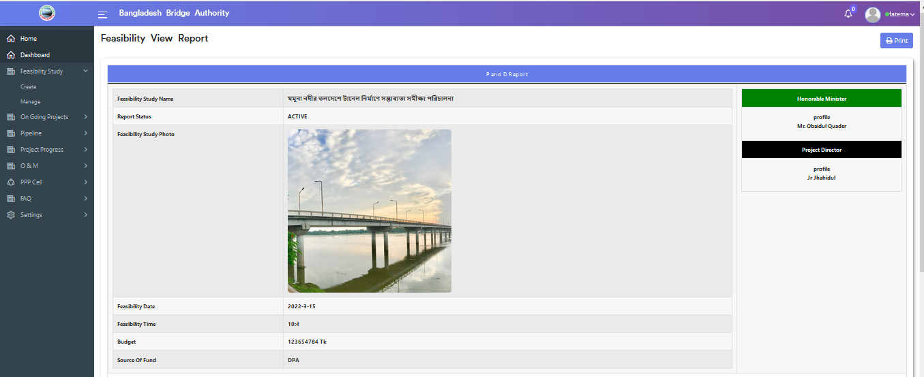

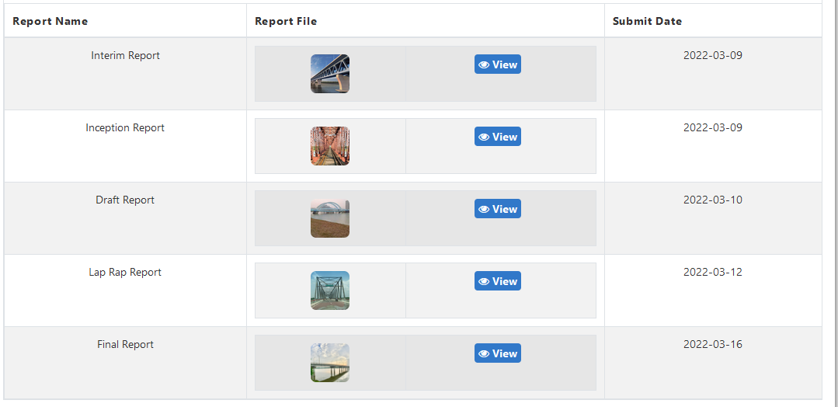

Figure 4.1.2.1: Manage (feasibility study ) view of single feasibility study Report

### 4.1.2.2: Manage (Feasibility Study) Print functionality

In the Manage (feasibility study ) view of single feasibility study report page if click on print button then printing functionality will appear which is like the below scenario.

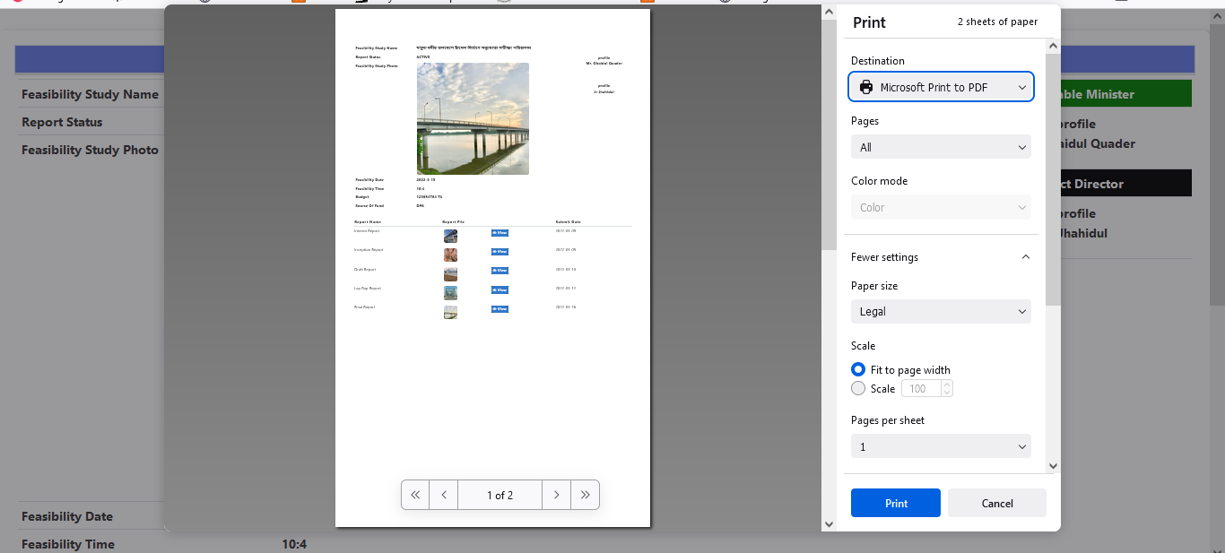

Figure 4.1.2.2: Manage (Feasibility study ) Print functionality

### 4.1.2.3: Manage (Feasibility Study ) Update Feasibility Study functionality

In Manage (feasibility study) data table if click on the edit button then the updated feasibility study input form will appear which is like the below scenario. User can update & delete data as per as user required.

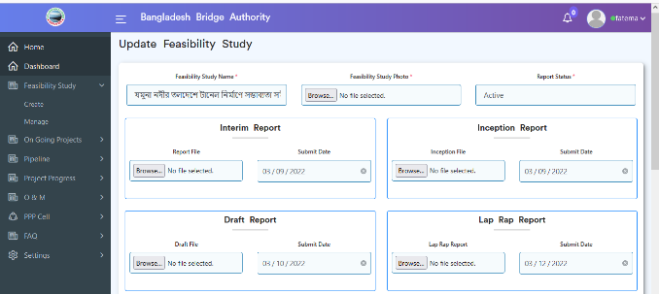

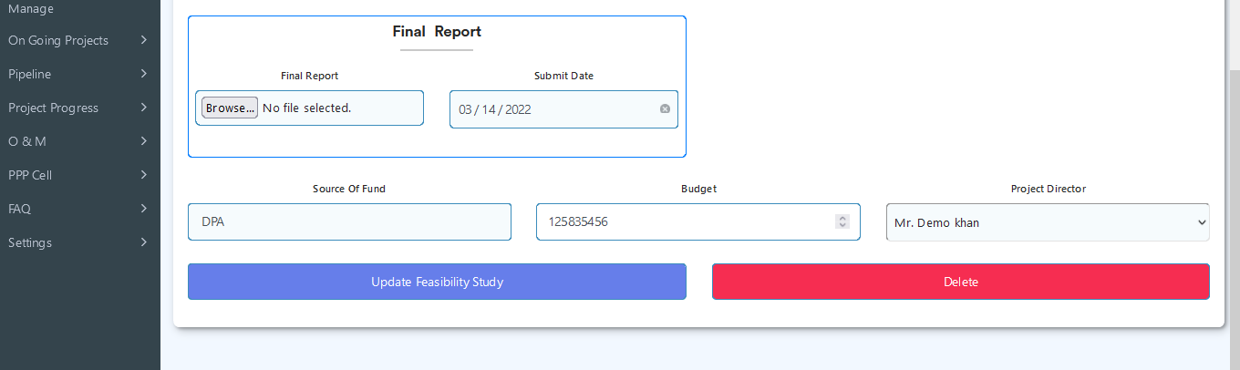

Figure 4.1.2.3: Manage (feasibility study ) Update feasibility study functionality

## 4.2: On Going Projects Overview

**Overview of On Going Project**

Click on the On Going Projects after that there will appear two sub menus and they are Create and Manage on going projects .

### 4.2.1:Create(On Going Project) Add new Construction Input Form

Click on the Create submenu after that add a new construction input form will appear as like below scenario. User must fill up the required input fields with appropriate values to store new construction record in the database.

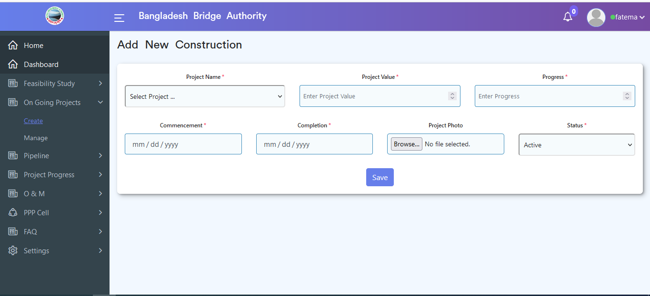

Figure 4.2.1: Create (On going project) add new construction Input form

### 4.2.2: Manage (On Going Project) View of Construction Details

Click on the Manage(on going project) submenu after that look like below construction data table will appear if data is available in the database .

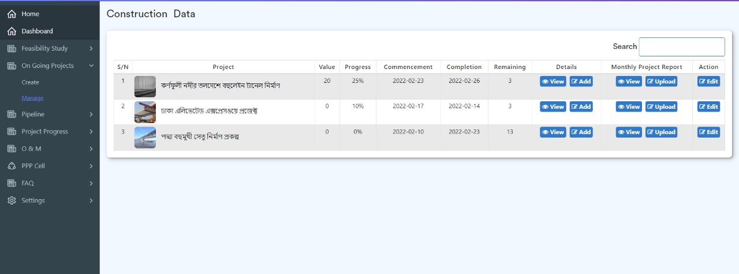

Figure 4.2.2: Manage (on going project) view of construction data

### 4.2.2.1: Manage (On Going Project) Add More Details

In the Manage (On Going Projects ) data table if click on the add more details button then the add more detail input form will appear which is like the below scenario .User must fill up the required input fields with appropriate values to store more construction data in the database.

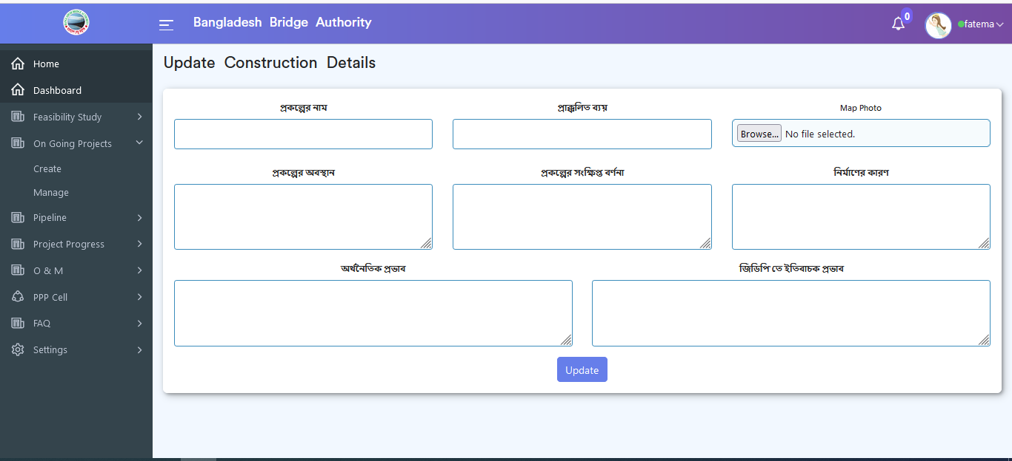

Figure 4.2.2.1: Manage (on going project) add more details

### 4.2.2.2: Manage (On Going Project) View of Monthly (All) Project Report

In the Manage (On Going Projects ) data table if click on the view button then all monthly project report will appear which is like the below scenario .

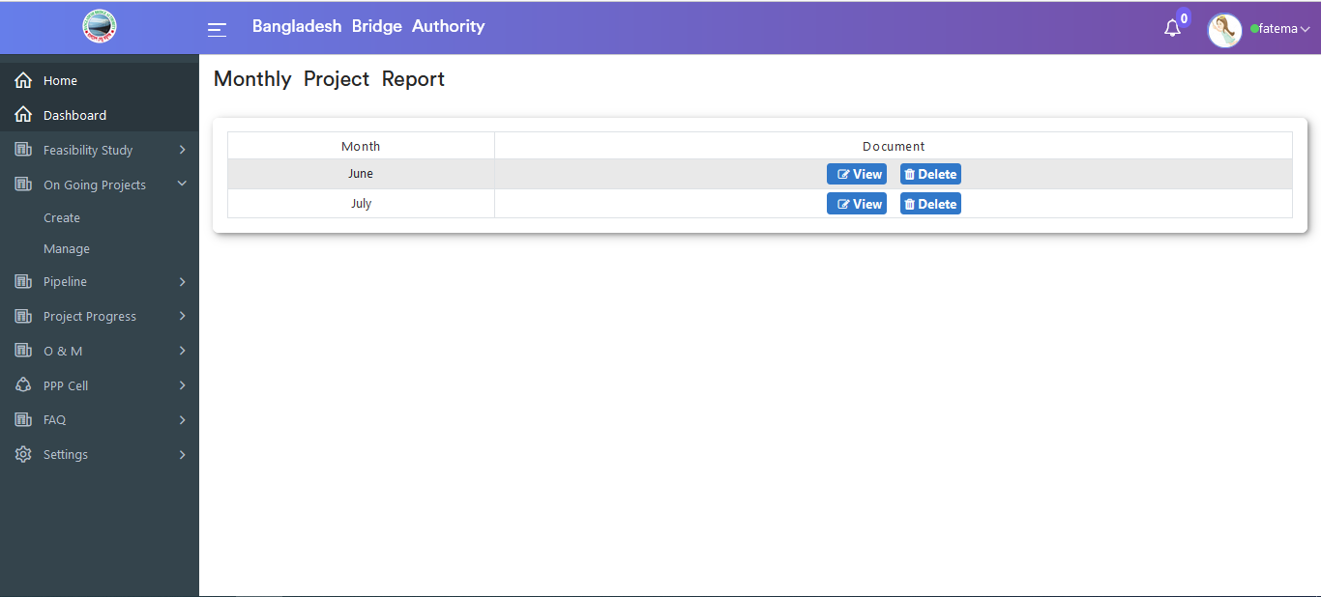

Figure 4.2.2.2: Manage (on going project) view of monthly (all) project report

### 4.2.2.3: Manage (On Going Project) View of Monthly (Single) Project Report

In the Manage (On Going Projects ) monthly(all) project report data table if click on the view button then single monthly project report will appear which is like the below scenario.



Figure 4.2.2.3: Manage (on going project) view of monthly(single) project report

### 4.2.2.4: Manage (On Going Project) Delete Monthly (Single) Project Report

In the Manage (On Going Projects ) monthly(all) project report data table if click on the delete button then single monthly project report will be deleted.

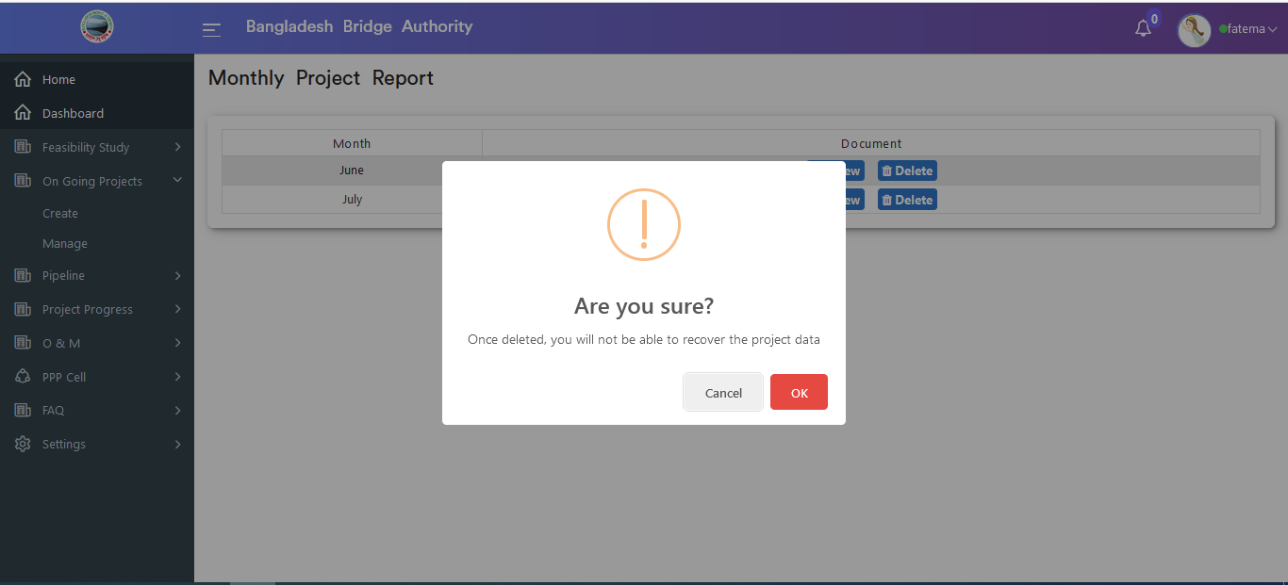

Figure 4.2.2.4: Manage (on going project) Delete monthly(single) project report

### 4.2.2.5: Manage (On Going Project) Upload Monthly Project Report

In the Manage (On Going Projects ) data table if click on the upload button then the monthly project report input form will appear which is like the below scenario. User can update & delete data as per as user required.

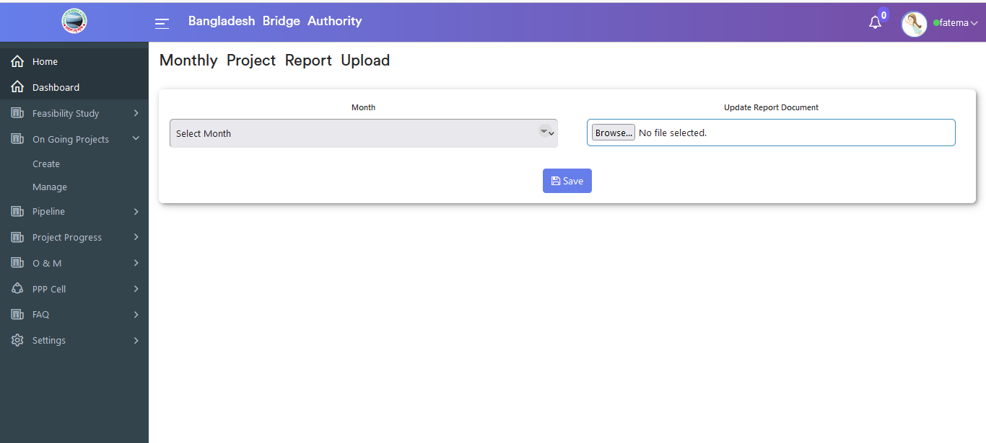

Figure 4.2.2.5: Manage (on going project) upload monthly project report

### 4.2.2.6: Manage (On Going Project) Update & Delete Construction functionality

In Manage (On Going Project ) construction data table if click on the edit button then the update construction input form will appear which is like the below scenario. User can update & delete data as per as user required.

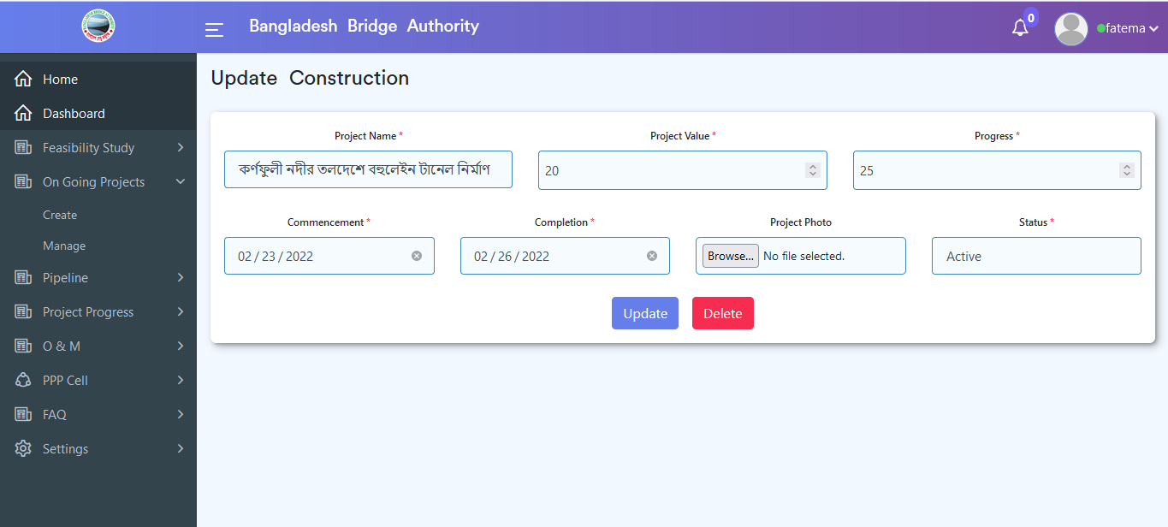

Figure 4.2.2.6: Manage (On going Project) Update & Delete Construction functionality

## 4.3: Pipeline Overview

**Overview of Pipeline**

Click on the Pipeline after that there will appear two submenus and they are Create and Manage Pipeline .

### 4.3.1: Create (Pipeline) Add New Pipeline Input Form

Click on the Create (pipeline) submenu after that add a new pipeline input form that will appear as the like below scenario . User must fill up the required input fields with appropriate values to store new pipeline record in the database.

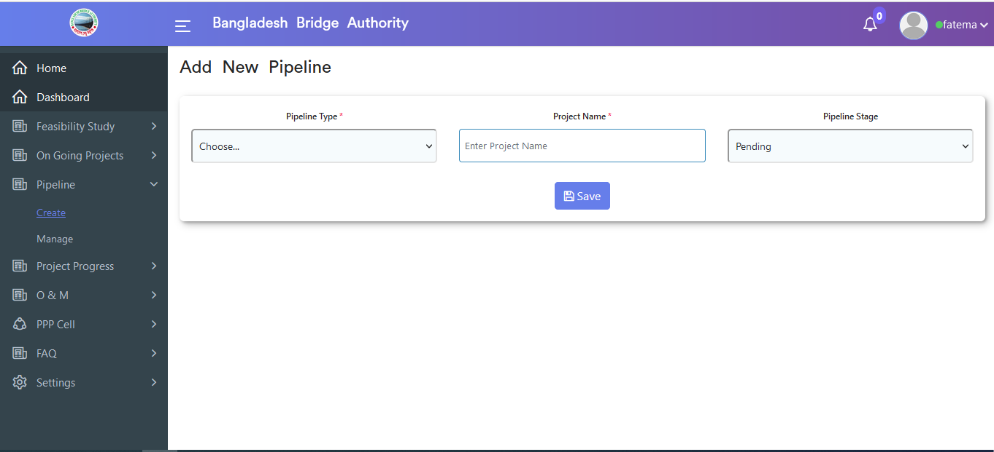

Figure 4.3.1: Create (pipeline) Add new pipeline Input form

### 4.3.2: Manage (Pipeline) View of Pipeline Data

Click on the Manage sub-menu after that looks like the below data table will appear if data is available in the database .

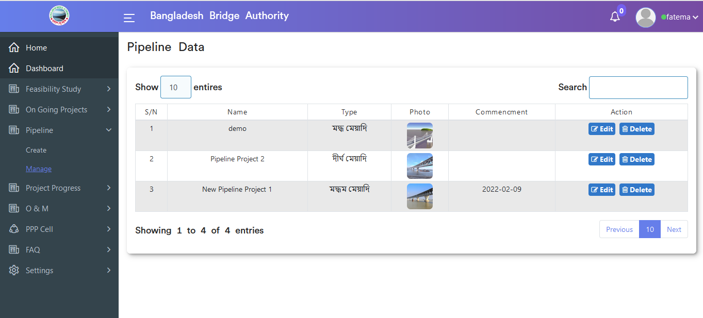 Figure 4.3.2: Manage (pipeline) View of Pipeline data

### 4.3.2.1: Manage (Pipeline) Edit functionality

In Manage (Pipeline ) data table if click on the edit button then the update pipeline input form will appear which is like the below scenario. User can update data as per as user required.

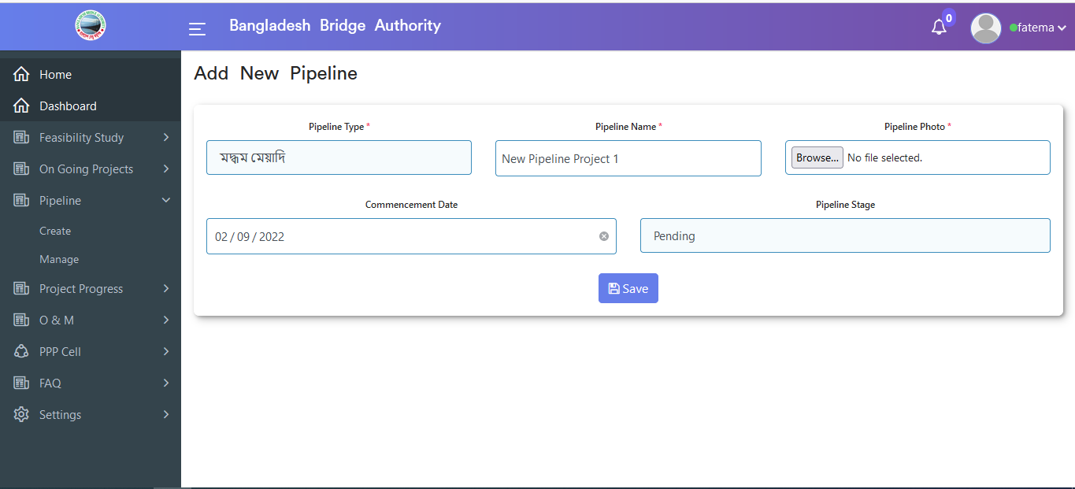

Figure 4.3.2-1: Manage (pipeline) edit functionality

### 4.3.2.2: Manage (Pipeline) Delete functionality

In Manage (Pipeline ) data table if click on the delete button then looks like a pop-up modal will appear. If click ok on the pop-up modal then data will be deleted.

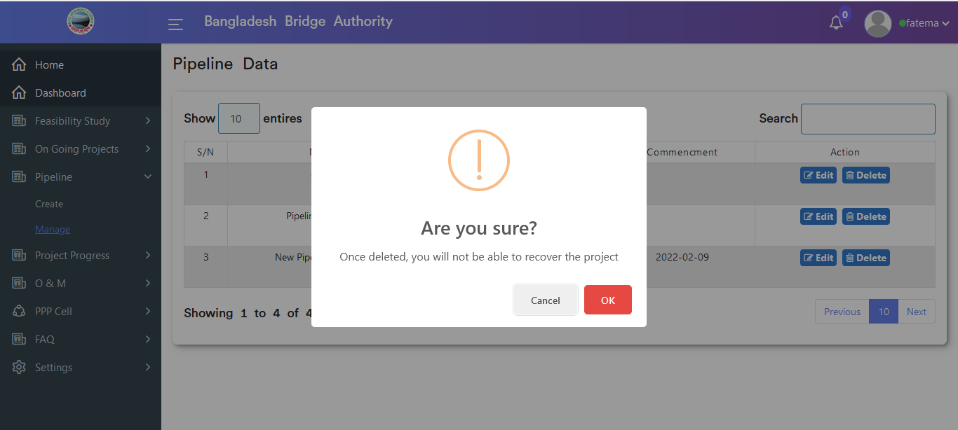

Figure 4.3.2-2: Manage (pipeline) delete functionality

## 4.4: Project Progress Overview

**Overview of Project Progress**

Click on the Project Progress after that there will appear three sub-menus and they are Create ,Manage and Photo Gallery .

### 4.4.1: Create (Project Progress) Add Construction of new projects & Add Details of project progress Input Form

Click on the Create sub-menu after that add new construction of new project & details of the project progress input form will appear as like below scenario . User must fill up the required input fields with appropriate values to store construction of new projects and details of project progress record in the database.

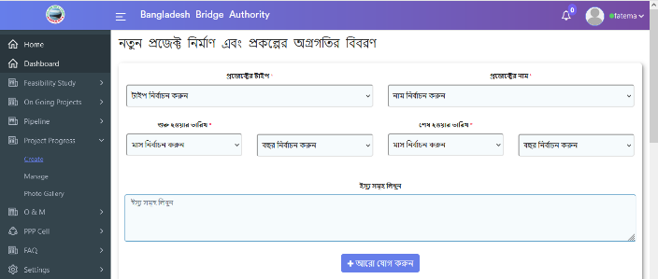

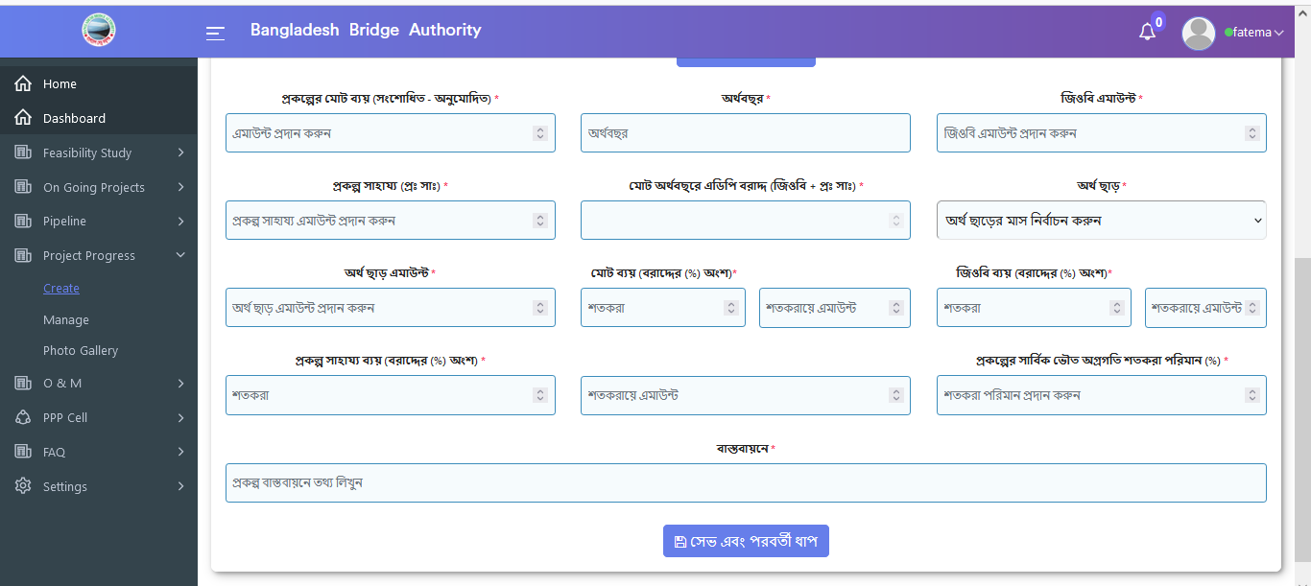

Figure 4.4.1: Create (Project Progress) add construction of new project & Add details of project progress Input form

### 4.4.2: Manage (Project Progress) View Of Project Data

Click on the Manage (Project Progress) submenu after that looks like the below data will appear if data is available in the database .

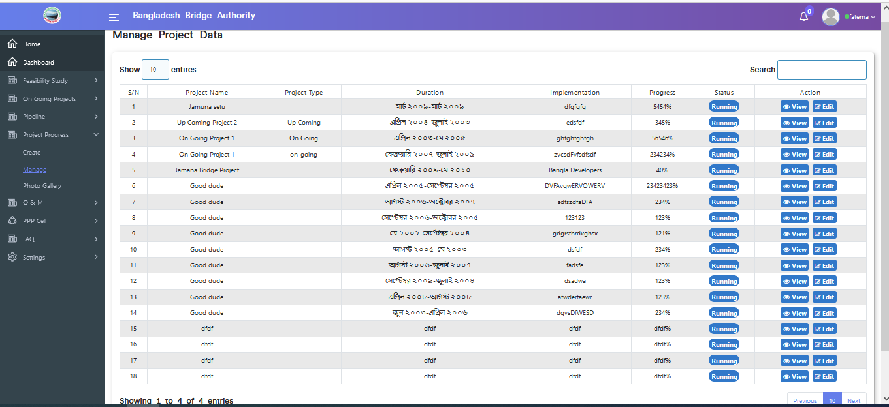

Figure 4.4.2: Manage (Project Progress) view of project data

### 4.4.2.1: Manage (Project Progress) View Of Construction Details

In Manage (Project Progress ) data table if click view button then looks like details of construction data will appear.

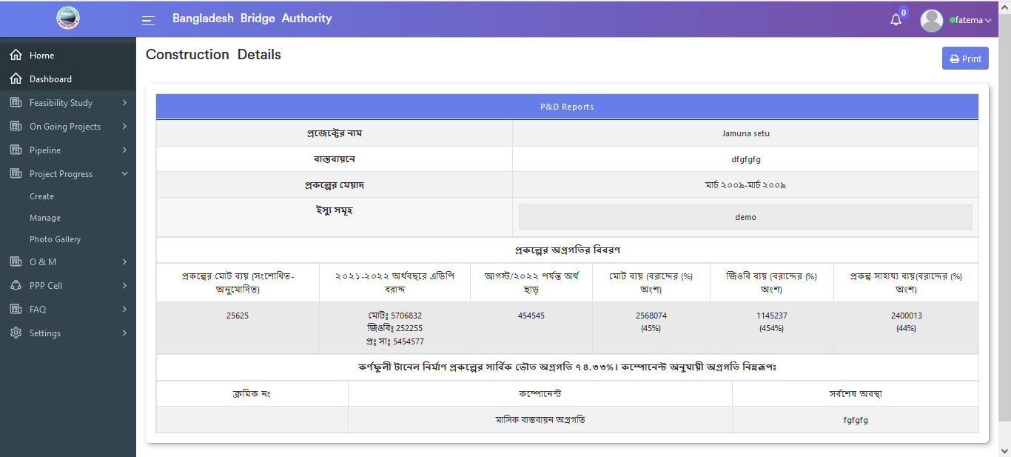

Figure 4.4.2.1: Manage (Project Progress) View of construction details

### 4.4.2.2: Manage (Project Progress) Print functionality

Print functionality is available on the manage (Project Progress ) construction details page & if click on the print button then looks like printing functionality will appear.

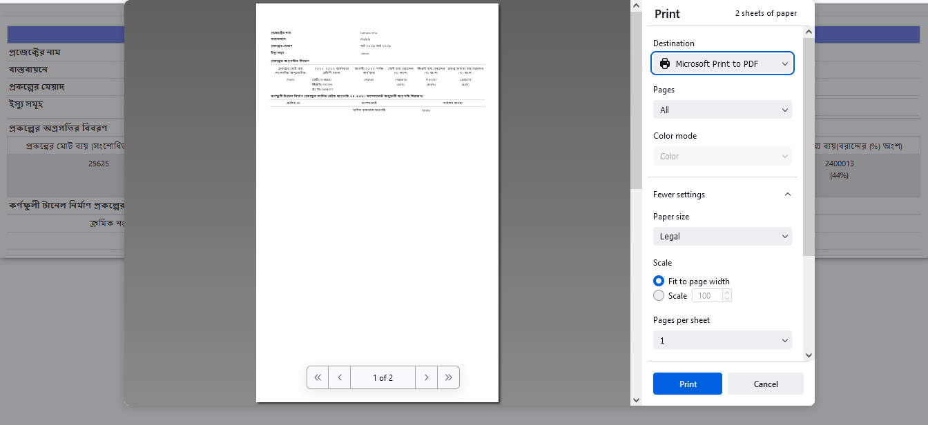 Figure 4.4.2.2: Manage (Project Progress) print functionality

### 4.4.2.3: Manage (Project Progress) Edit functionality

In Manage (Project Progress ) data table if click on the edit button then update the construction of the new project and details of the project progress input form will appear which is like the below scenario. User can change data as per as user required.

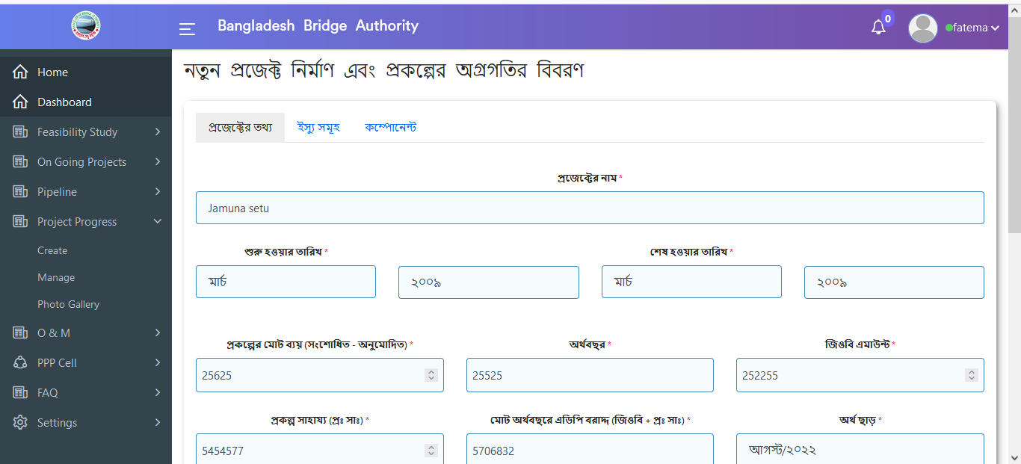

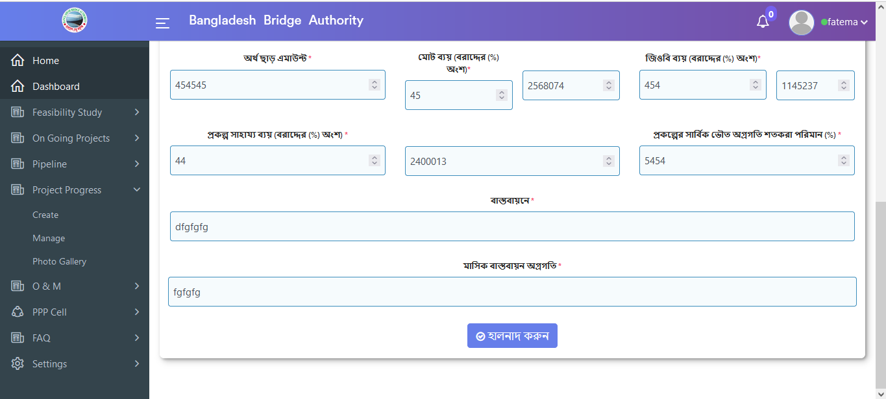

Figure 4.4.2.3: Manage (Project Progress) edit functionality(Project info update form)

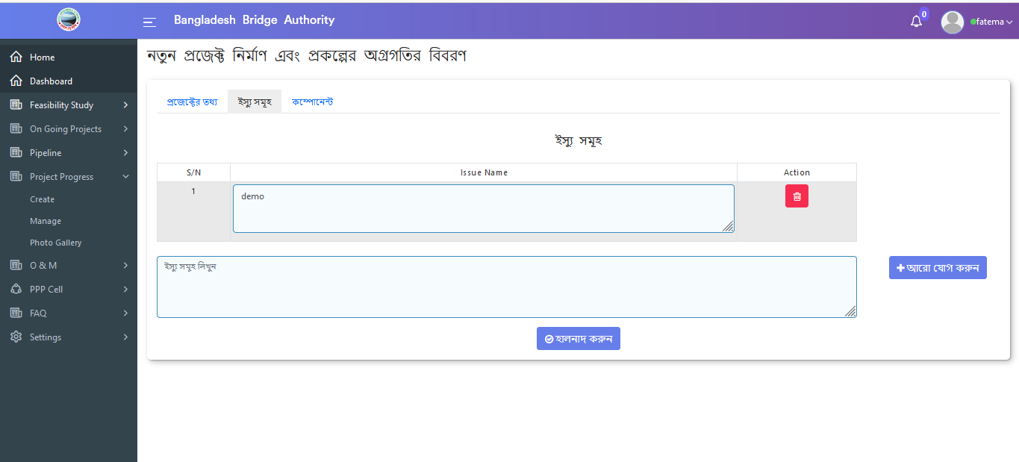

Figure 4.4.2.4: Manage (Project Progress) edit functionality (Issues info update form)

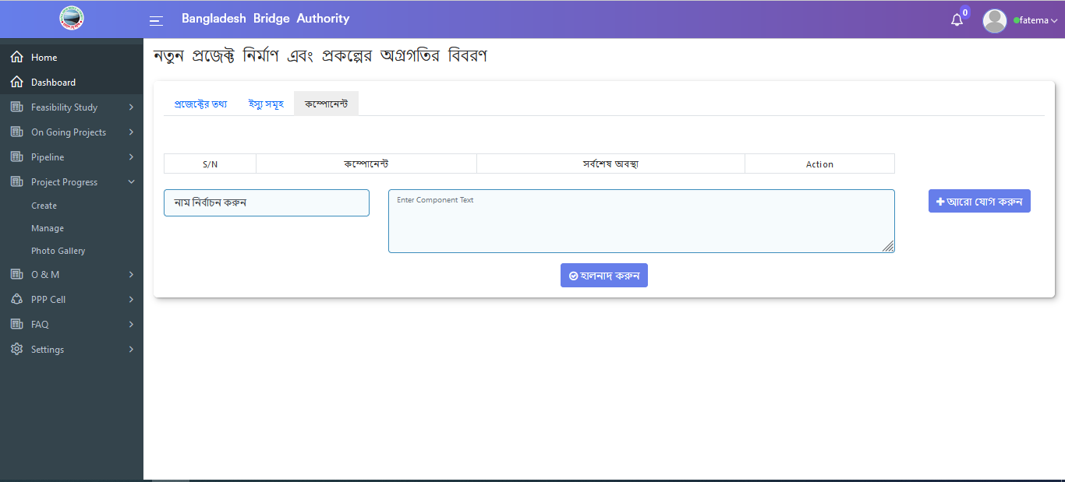

Figure 4.4.2.5: Manage (Project Progress) edit functionality (Component update form)

### 4.4.3: Photo Gallery (Project Progress) View Of Photo Gallery Data

Click on the Photo Gallery(Project Progress) sub-menu after that looks like the below data will appear if gallery data is available in the database .

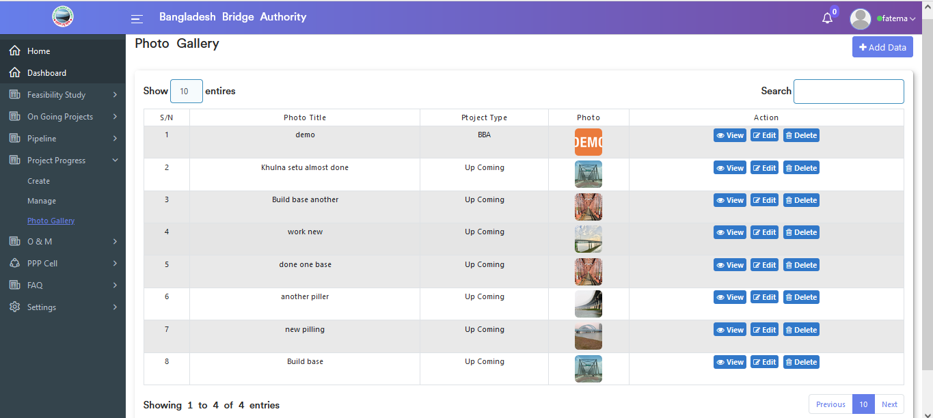

Figure 4.4.3: Photo Gallery (Project Progress) view of Photo gallery data

#### 4.4.3.1: Photo Gallery (Project Progress) Add Data input form

In Photo Gallery(Project Progress) if click on add data button after that looks like the below add input form will appear. User must fill up the required input fields with appropriate values to store photo gallery data in the database.

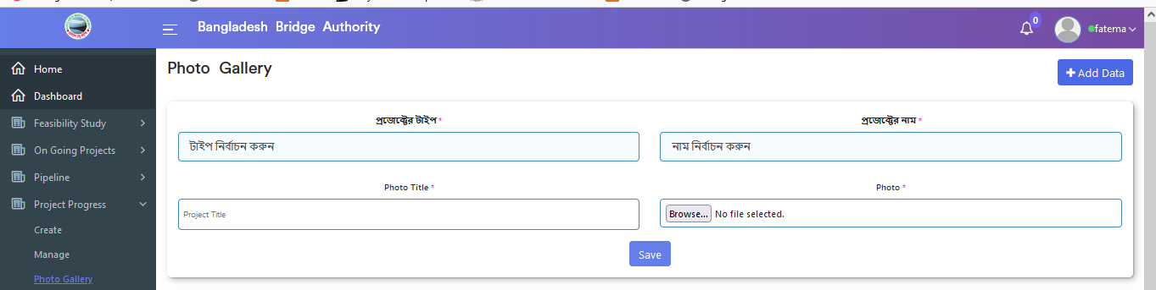

Figure 4.4.3.1: photo gallery (Project Progress) Add data input form

#### 4.4.3.2: Photo Gallery (Project Progress) View of a single gallery

In Photo Gallery (Project Progress ) data table if click view button then looks like details data of the photo gallery will appear.

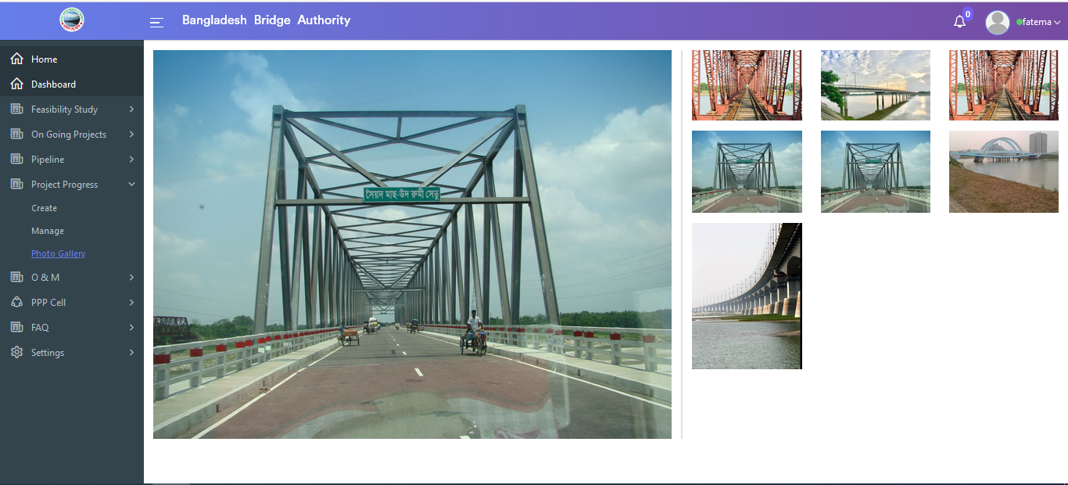

Figure 4.4.3.2:Photo gallery (Project Progress)View of single gallery

### 4.4.3.3: Photo Gallery (Project Progress) Edit Gallery Data

In Photo Gallery (Project Progress ) data table if click on the edit button then the Update gallery data input form will appear which is like the below scenario. User has the privilege to update data as per as user required.

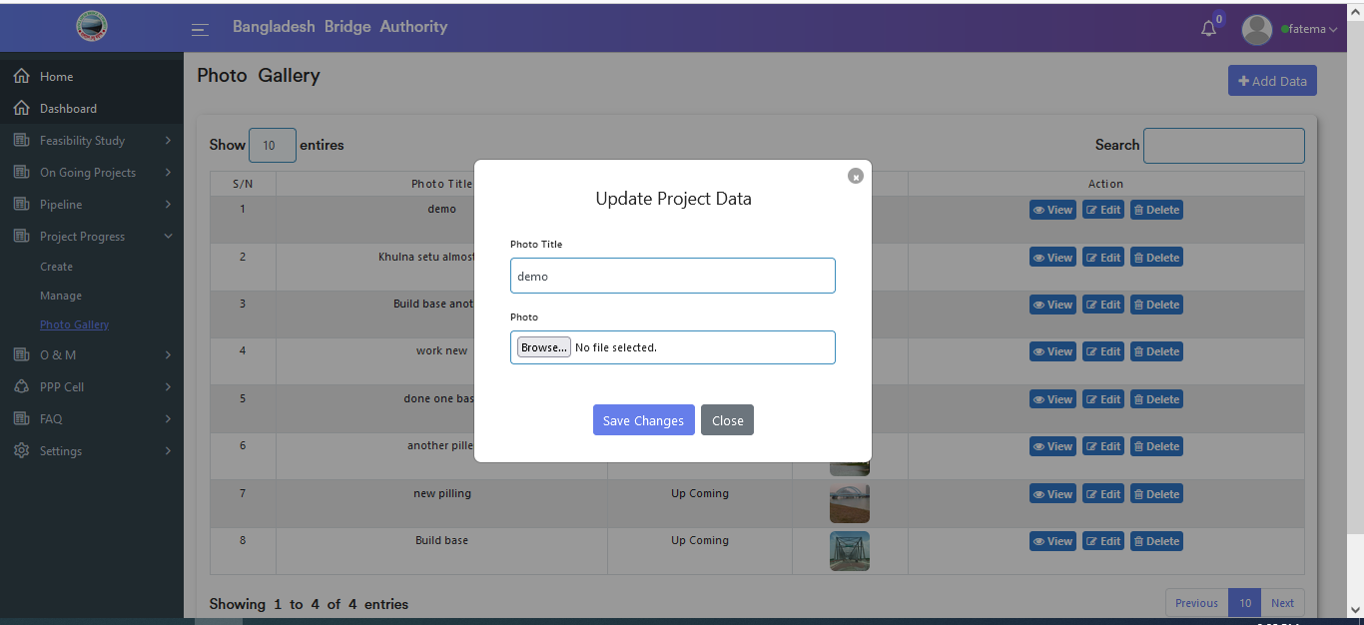

Figure 4.4.3-3:Photo gallery (Project Progress)Edit Gallery Data

#### 4.4.3.4: Photo Gallery (Project Progress) Delete Gallery Data

In Photo Gallery (Project Progress ) data table if click on the delete button then looks like a pop-up modal will appear. If click ok on the pop-up modal then data will be deleted.

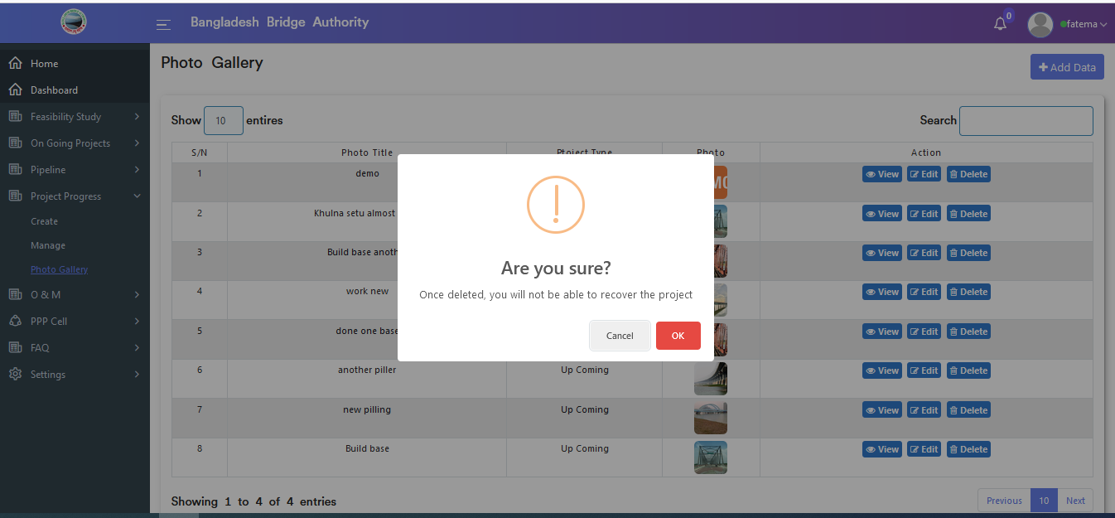

Figure 4.4.3-4: Photo gallery (Project Progress) delete gallery Data

## 4.5: O & M (Operations And Maintenance) Overview

**Overview of Operations & Maintenance**

Click on the O & M after that there will appear two sub-menus and they are Create and Manage O & M .

### 4.5.1: Create (O & M) Add New Operations & Maintenance Input Form

Click on the Create(O & M) sub-menu after that add a new operation & maintenance input form will appear as like below scenario . User must fill up the required input fields with appropriate values to store O & M record in the database.

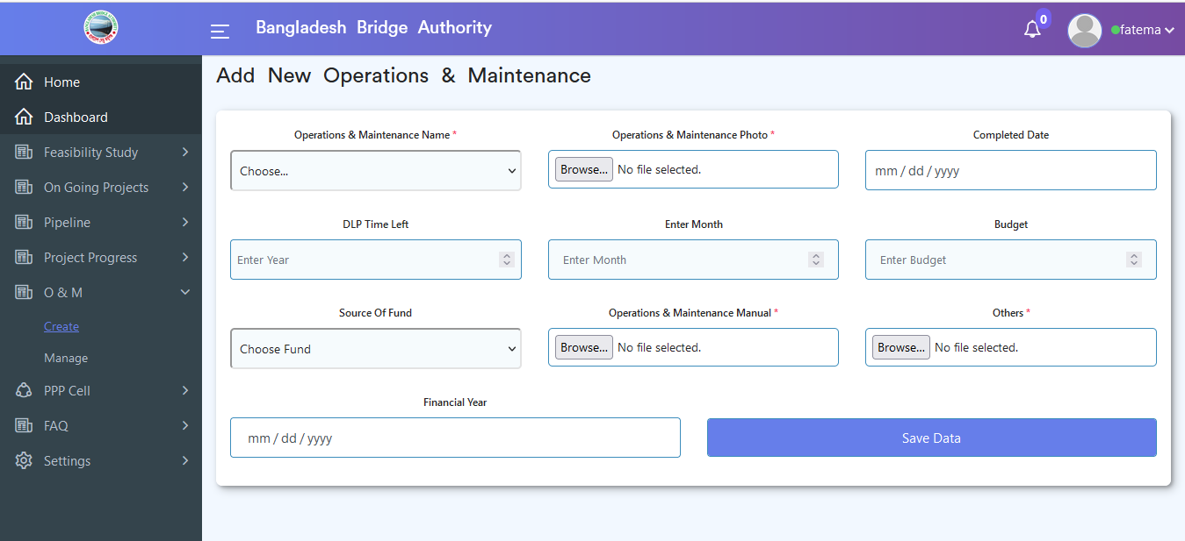

Figure 4.5.1: Create (O & M) add new operations and maintenance Input form

### 4.5.2: Manage (O & M) View of Operations & Maintenance Data

Click on the Manage sub-menu after that look like below (O & M) data will appear if operations & maintenance data is available in the database .

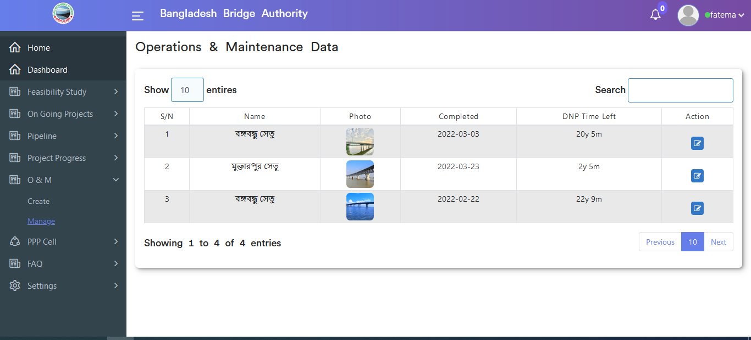

Figure 4.5.2: Manage (O & M) view of Operations & Maintenance Data

### 4.5.2.1: Manage (O & M) Update Operations & Maintenance Data

In Manage (O & M ) data table if click on the edit button the update operations & maintenance data input form will appear which is like the below scenario. User can update & delete data as per as user required.

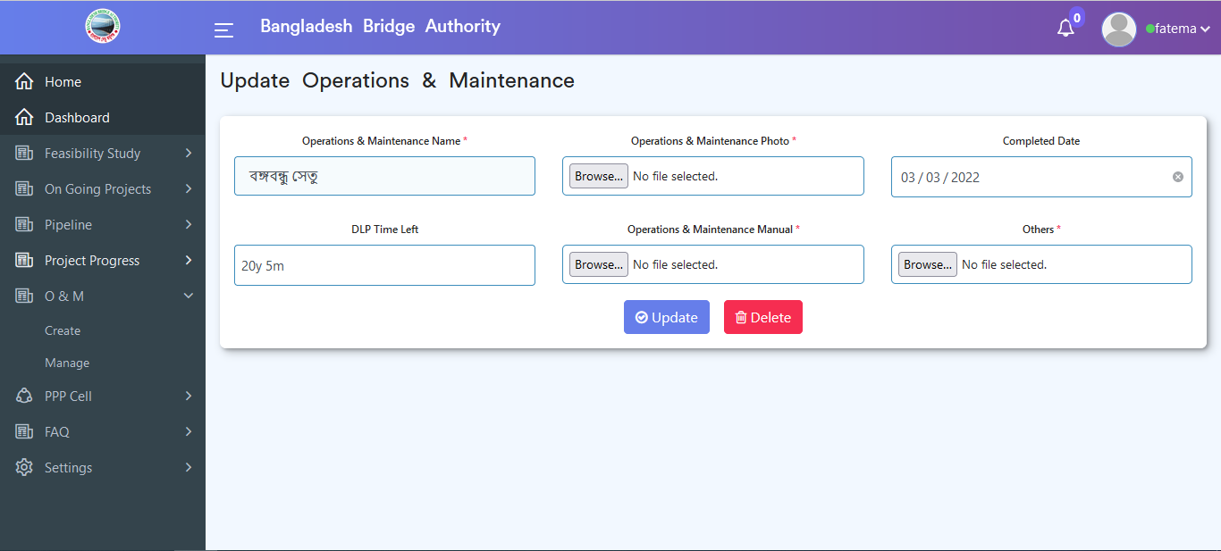

Figure 4.5.2: Manage (O & M) update Operations & Maintenance Data

## 4.6: PPP Cell Overview

**Overview of PPP Cell**

Click on the PPP Cell after that there will appear three sub-menus and they are **About PPP Cell** , **Upcoming PPP Project** and **On Going PPP Project**. Upcoming PPP Project sub-menu has also two sub menus and they are **create** sub-sub-menu and **manage** sub-sub-menu.On Going PPP Project also has two sub-menu they are **create** sub sub-menu and **manage** sub sub-menu.

### 4.6.1: About PPP Cell(PPP Cell) View of about ppp cell

Click on the About PPP Cell sub-menu after that looks like below data will appear if about ppp cell data is available in the database .

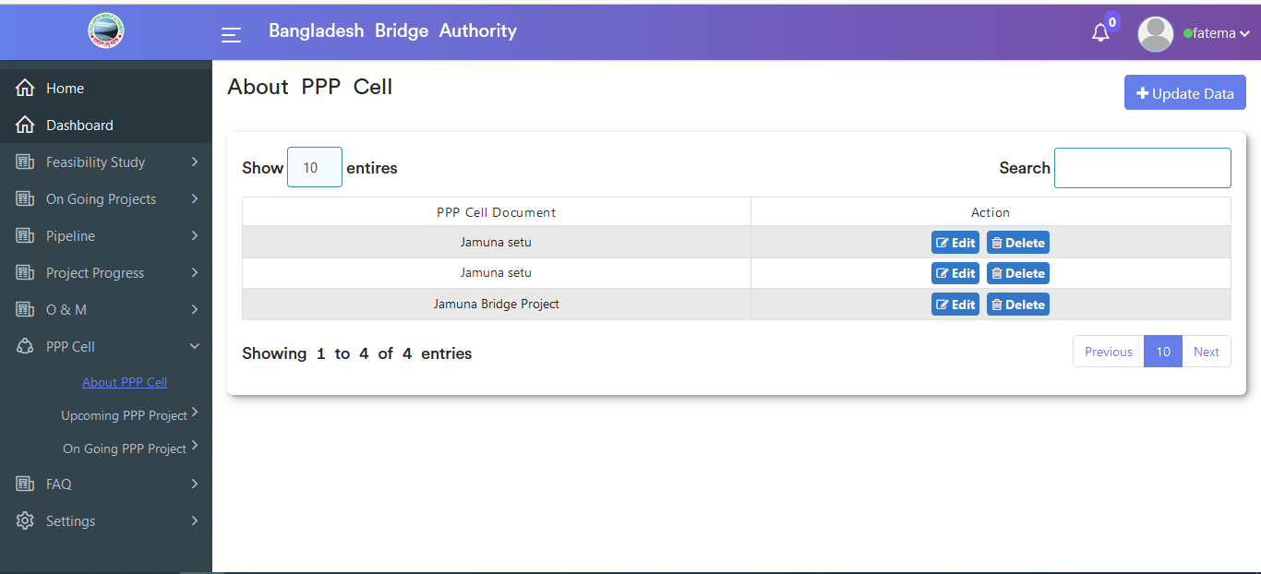

Figure 4.6.1: About ppp cell(ppp cell) view of about ppp cell

#### 4.6.1.1: About PPP Cell(PPP Cell) Update ppp cell document

In the About ppp cell (PPP Cell) sub-menu if click on the Update Data button then update ppp cell document input form will appear which is like the below scenario. User can update data as per as user required.

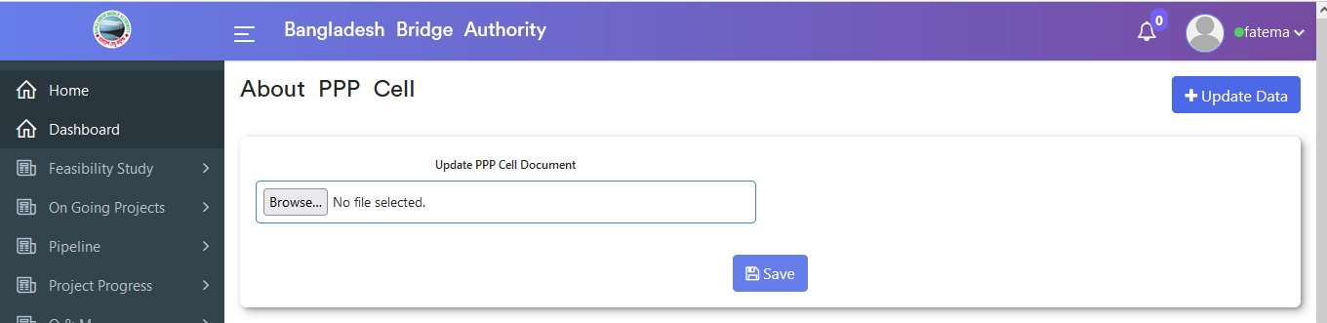

Figure 4.6.1.1: About ppp cell(ppp cell) Update ppp cell document

#### 4.6.1.2: About PPP Cell(PPP Cell) Edit Data

In About ppp cell (PPP Cell ) data table if click on the edit button then a pop-up modal input form will appear which is like the below scenario. User can change data as per as user required.

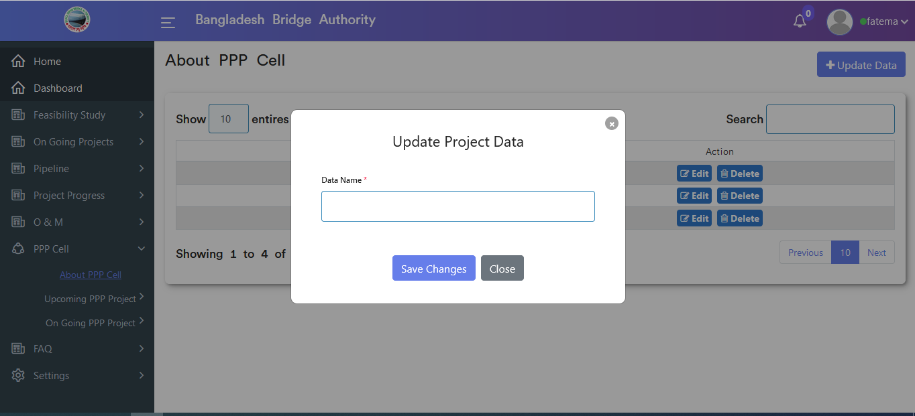

Figure 4.6.1.2: About ppp cell (ppp cell) edit data

#### 4.6.1.3: About PPP Cell(PPP Cell) Delete Data

In About ppp cell (ppp cell ) data table if click on the delete button then looks like a pop-up modal will appear. If click ok on the pop-up modal then data will be deleted.

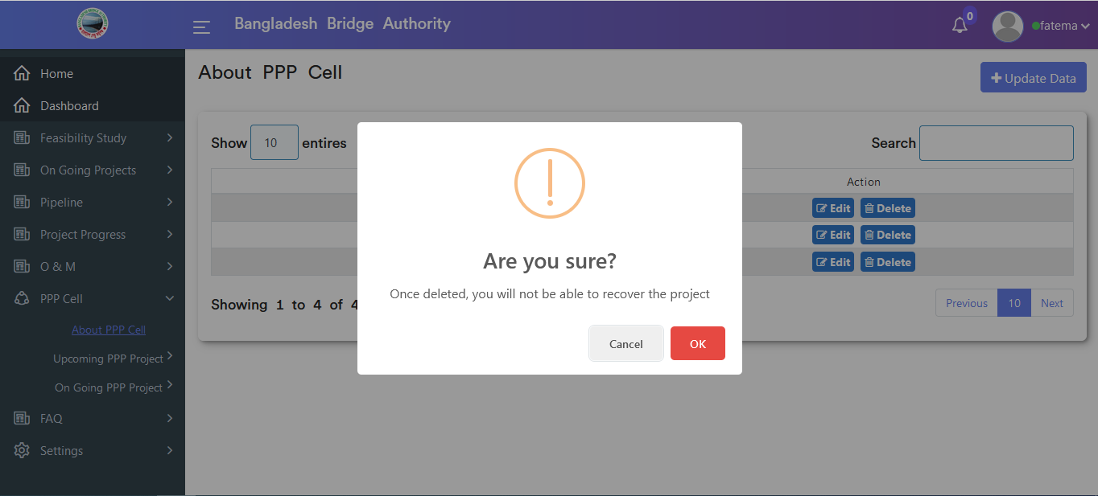

Figure 4.6.1.3:About ppp cell (ppp cell) delete data

### 4.6.2.1: Create-Upcoming ppp project-(PPP Cell) Upcoming ppp project create input from

Click on the sub sub-menu after that upcoming ppp project create input form will appear as like below scenario . User must fill up the required input fields with appropriate values to store upcoming ppp project record in the database.

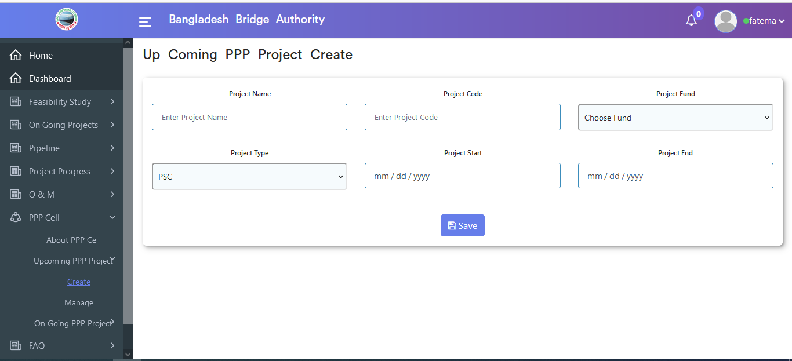

Figure 4.6.2.1: Create-upcoming ppp project -(ppp cell) upcoming ppp project create input form

### 4.6.2.2: Manage-Upcoming ppp project-(PPP Cell) View of upcoming ppp project data

Click on the manage sub sub-menu after that looks like below data will appear if upcoming ppp project data is available in the database.

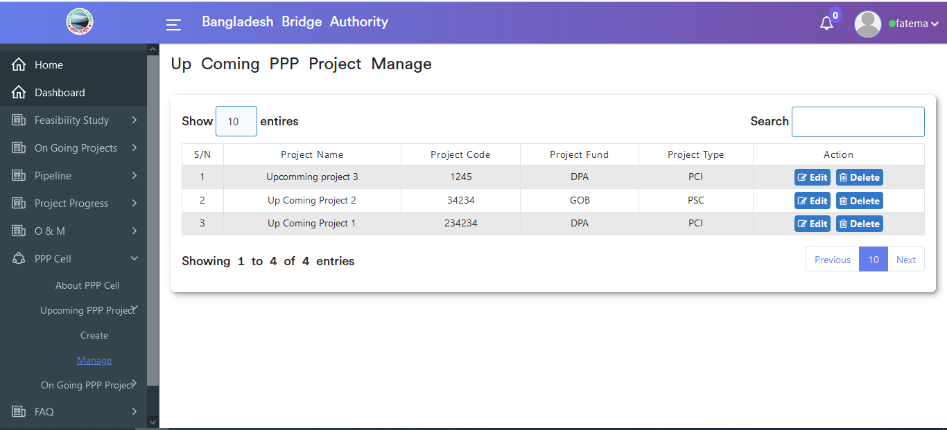

Figure 4.6.2.2: Manage upcoming ppp project (ppp cell) view of upcoming ppp project data

#### 4.6.2.2.1: Manage-Upcoming ppp project-(PPP Cell) Search

User can search data by project name from the upcoming ppp project data table.

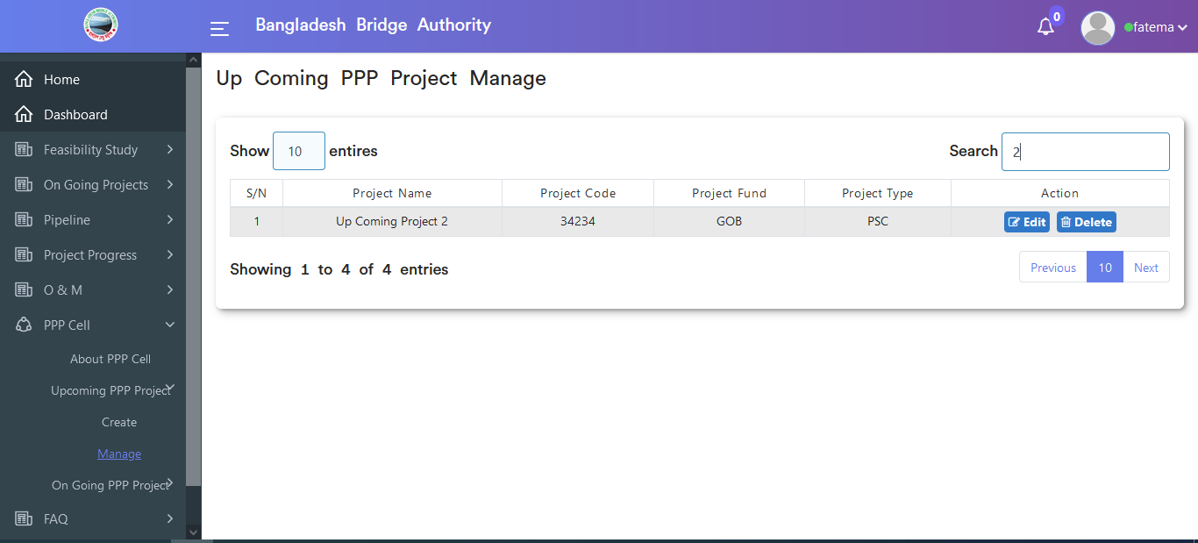

Figure 4.6.2.2.1: Manage upcoming ppp project (ppp cell) Search

#### 4.6.2.2.2: Manage-Upcoming ppp project-(PPP Cell) Update upcoming project

In Manage (upcoming ppp project) (ppp cell ) data table if click on the edit button then update upcoming project input form will appear which is like the below scenario. User has can change data as per as user required.

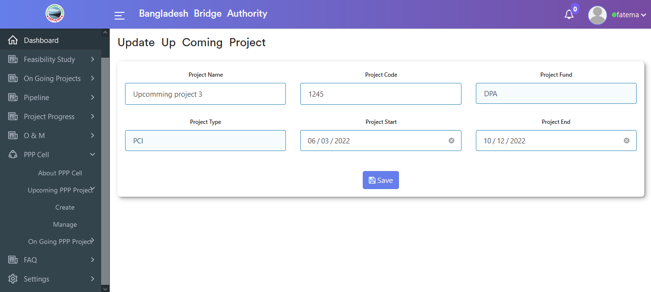

Figure 4.6.2.2.2: Manage upcoming ppp project (ppp cell) update upcoming project

#### 4.6.2.2.3: Manage-Upcoming ppp project-(PPP Cell) Delete

In Manage (upcoming ppp project) (ppp cell ) data table if click on the delete button then looks like a pop-up modal will appear. If click ok on the pop-up modal then data will be deleted.

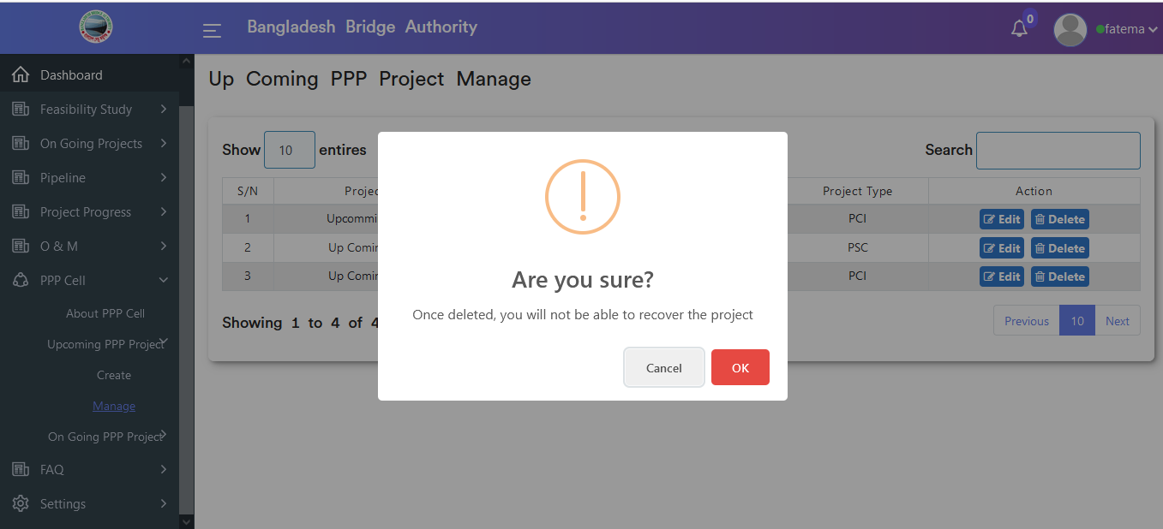

Figure 4.6.2.2.3: Manage upcoming ppp project (ppp cell) delete

### 4.6.3.1: Create-Ongoing ppp project-(PPP Cell) Ongoing ppp project create input from

Click on the Create sub sub-menu after that ongoing ppp project create input form will appear as like below scenario . User must fill up the required input fields with appropriate values to store ongoing ppp project record in the database.

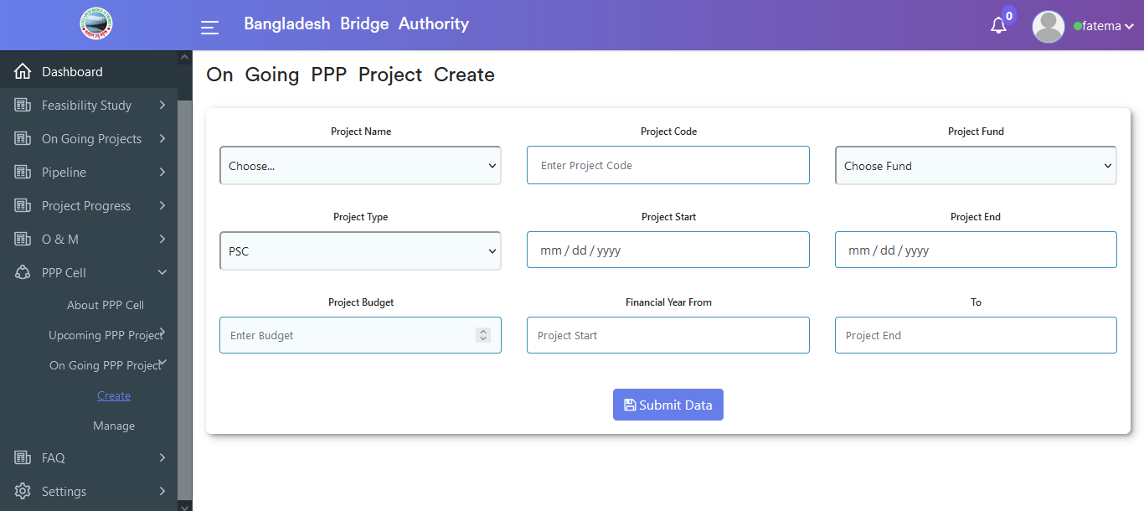

Figure 4.6.3.1: Create- ongoing ppp project -(ppp cell) ongoing ppp project create an input form

### 4.6.3.2: Manage-Ongoing ppp project-(PPP Cell) View of ongoing ppp project data

Click on the manage sub-menu after that looks like below data table will appear if upcoming ppp project data is available in the database.

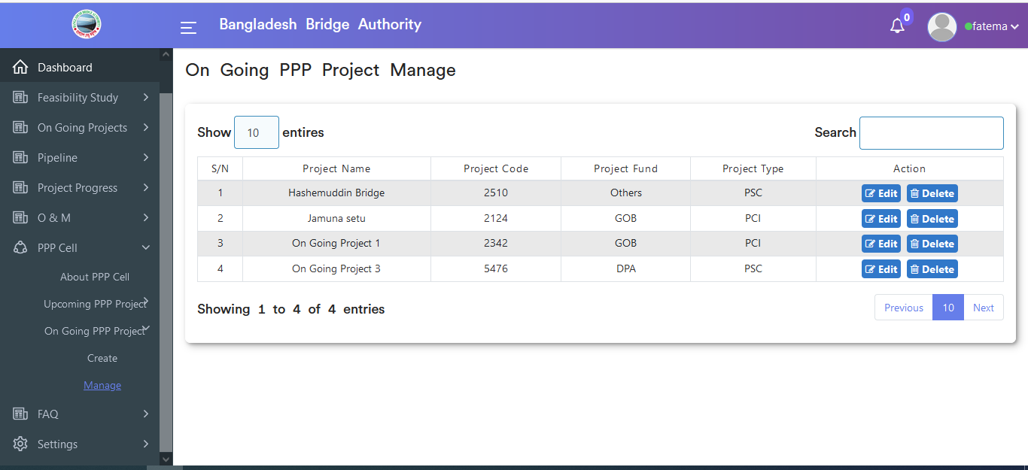

Figure 4.6.3.2: manage ongoing ppp project (ppp cell) view of ongoing ppp project data

### 4.6.3.2.1: Manage-Ongoing ppp project-(PPP Cell) Search

User can search data by project name from the ongoing ppp project data table.

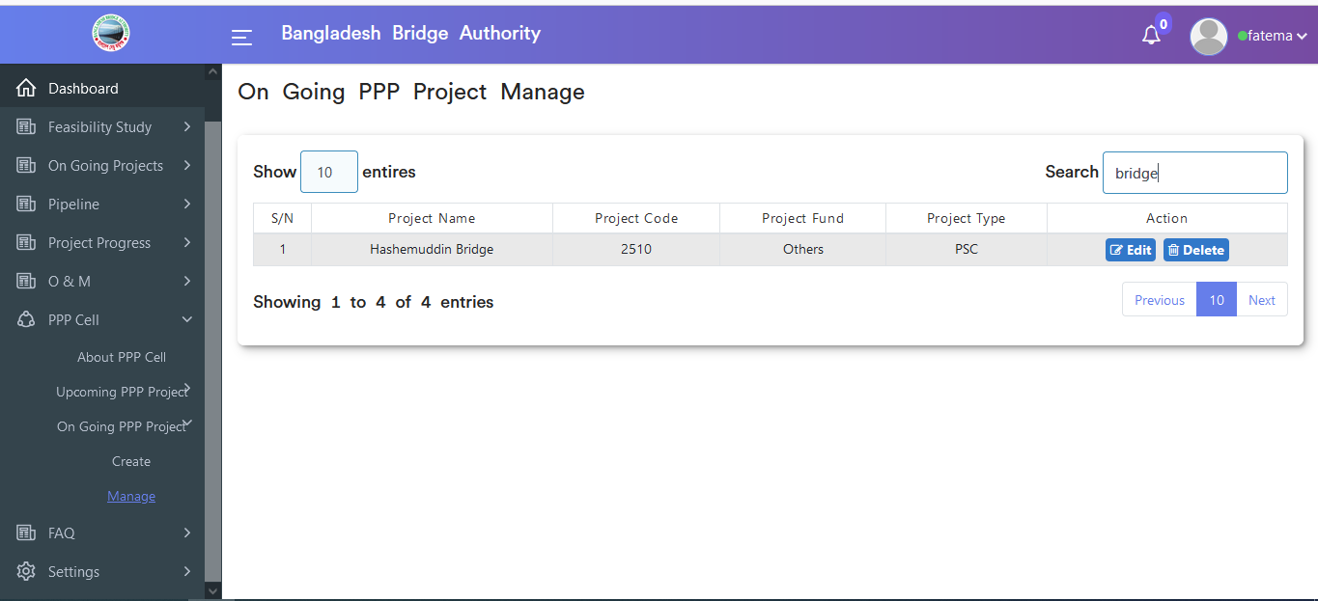

Figure 4.6.3.2.1: manage ongoing ppp project (ppp cell) search

### 4.6.3.2.2: Manage-Ongoing ppp project-(PPP Cell) Update ongoing project

In Manage (ongoing ppp project) (ppp cell ) data table if click on the edit button then update ongoing project input form will appear which is like the below scenario. User has the privilege to update data as per as user required.

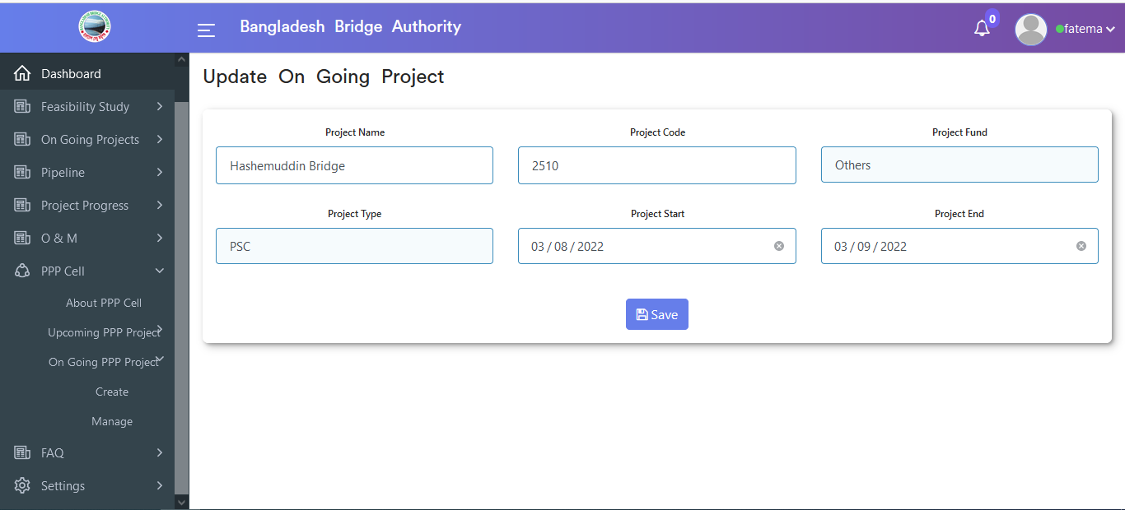

Figure 4.6.3.2.2: manage- ongoing ppp project -(ppp cell) update ongoing project

### 4.6.3.2.3: Manage-Ongoing ppp project-(PPP Cell) Delete

In Manage ongoing ppp project (ppp cell ) data table if click on delete button then looks like pop-up modal will appear. If click ok on the pop-up modal then data will be deleted.

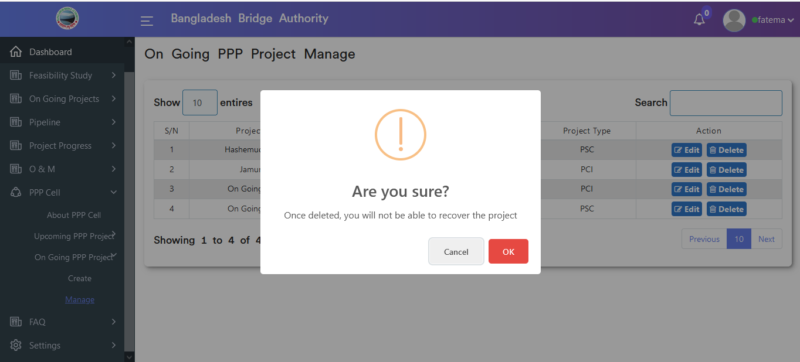

Figure 4.6.3.2.3: manage- ongoing ppp project- (ppp cell) delete

## 4.7: FAQ Overview

**Overview of FAQ**

Click on FAQ after that there will appear create sub-menu.

### 4.7.1: Create (FAQ) View of faq data

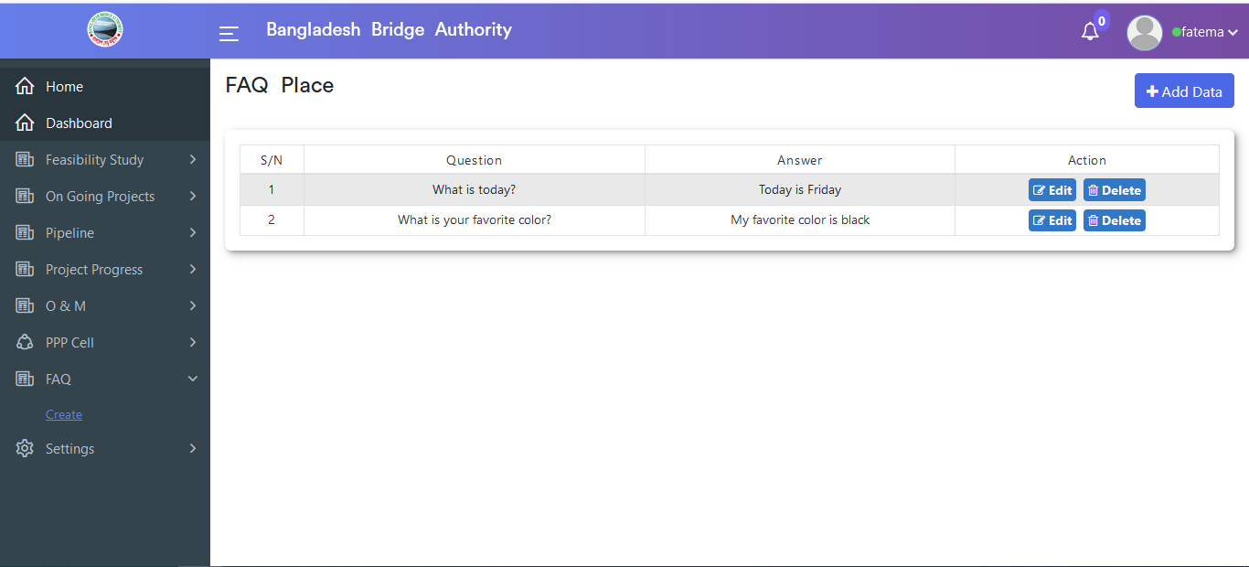

Figure 4.7.2: create (faq) view of faq data

### 4.7.2: Create (FAQ) Add Data input form

In Create (FAQ) data table click on the Add data button after that Faq place input form will appear as like the below scenario .User must fill up the required input fields with appropriate values to store faq questions record in the database.

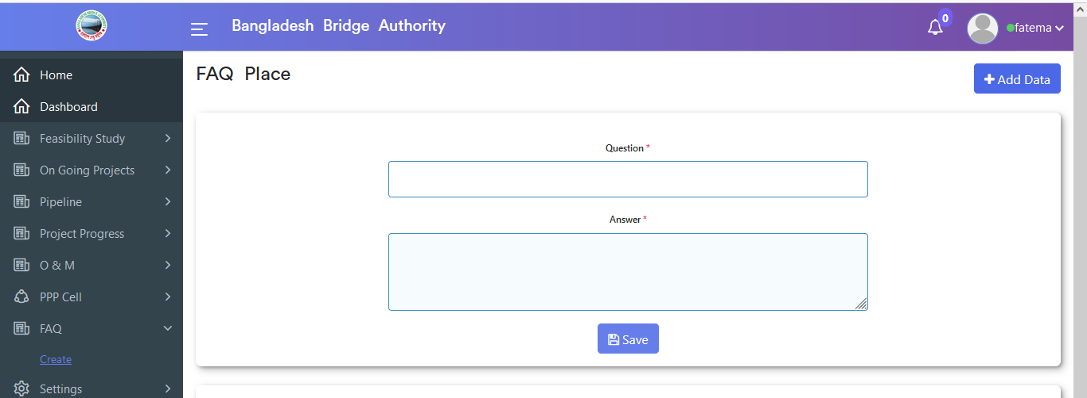

Figure 4.7.2: create (faq) add data input form

### 4.7.3: Create (FAQ) Edit

In Create (FAQ ) data table if click on the edit button then pop-up modal input form will appear which is like the below scenario. User can change data as per as user required.

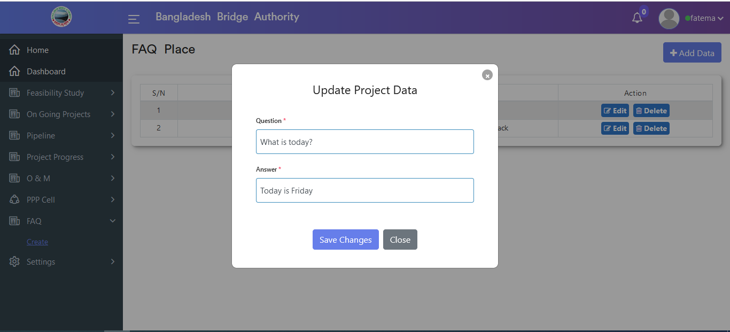

Figure 4.7.3: create (faq) edit data

### 4.7.4: Create (FAQ) Delete

In create (FAQ) data table if click on the delete button then looks like a pop-up modal will appear. If click ok on the pop-up modal then data will be deleted.

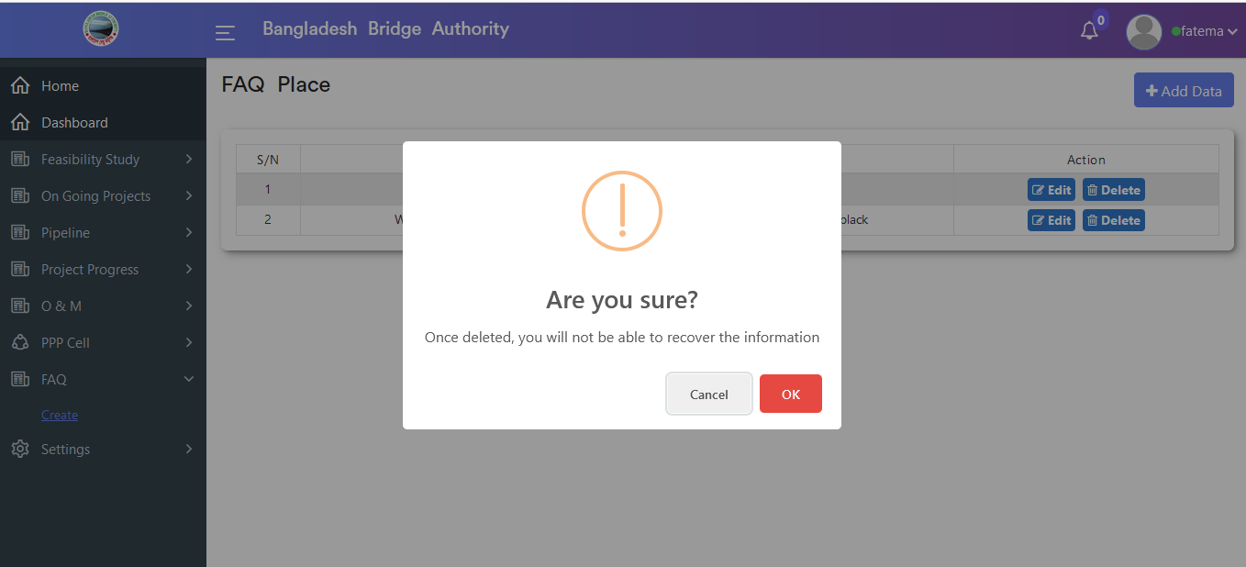

Figure 4.7.4: create (faq) delete data

## 4.8: Settings Overview

**Overview of Settings**

Click on the settings menu after that there will appear three sub-menu & they are **FCP**, **Component Data** and **Project Data**

### 4.8.1.1: FCP(Settings) View of fcp data

Click on the fcp(settings) sub-menu after that looks like scenario will appear if data is available in the database.

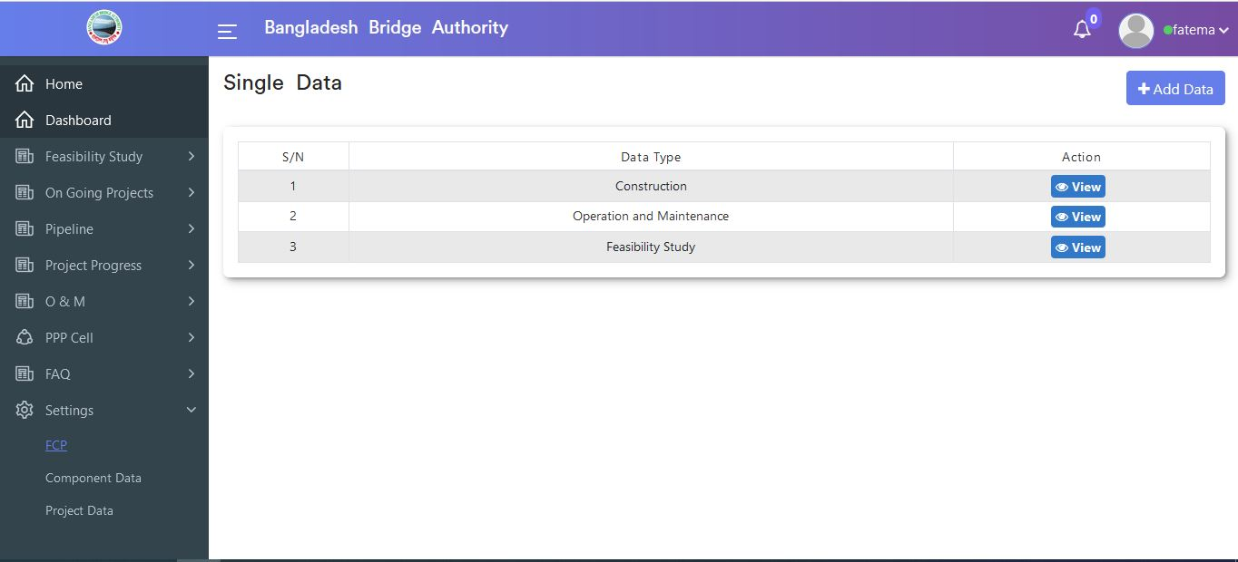

Figure 4.8.1.1: fcp (settings) view of fcp data

### 4.8.1.2: FCP(Settings) Add data input form

In FCP (settings) sub-menu click on the Add data button after that input form will appear as like below scenario . User must fill up the required input fields with appropriate values to store the fcp record in the database.

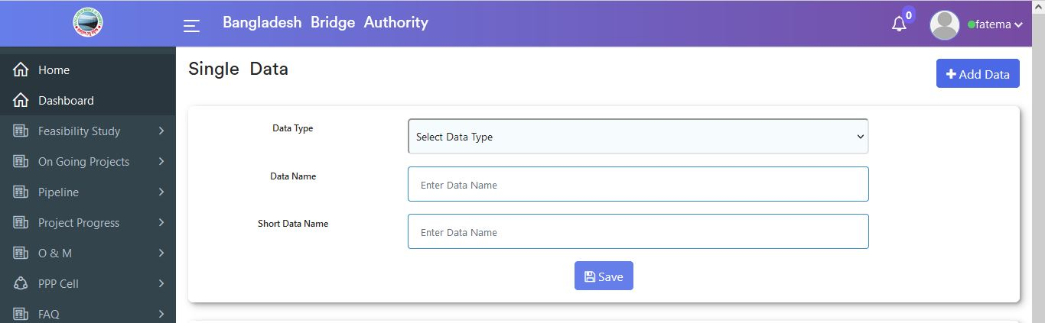

Figure 4.8.1.2: fcp (settings) Add data input form

### 4.8.1.3: FCP(Settings) View of fcp single data

In FCP (Settings) data table if click on view button then looks like single data of fcp will appear.

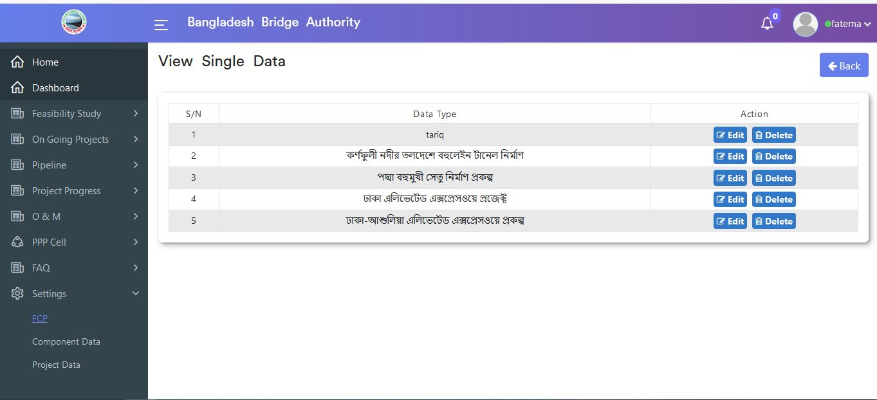

Figure 4.8.1.3: fcp (settings) view fcp single data

### 4.8.1.4: FCP(Settings) View of fcp single data edit

In the FCP (Settings ) view of single data table if click on the edit button then pop-up modal input form will appear which is like the below scenario. User can change data as per as user required.

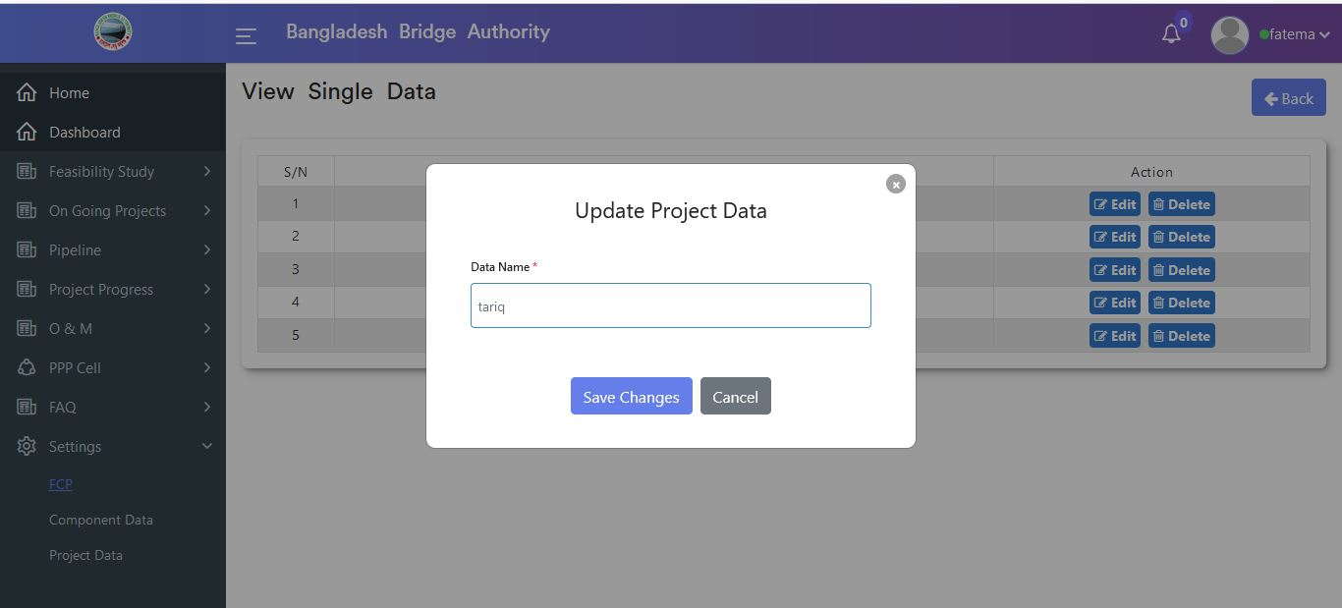

Figure 4.8.1.4: fcp (settings) view of fcp single data edit

### 4.8.1.5: FCP(Settings) View of fcp single data delete

In the FCP (Settings) view of single data table if click on the delete button then looks like a pop-up modal will appear. If click ok on the pop-up modal then data will be deleted.

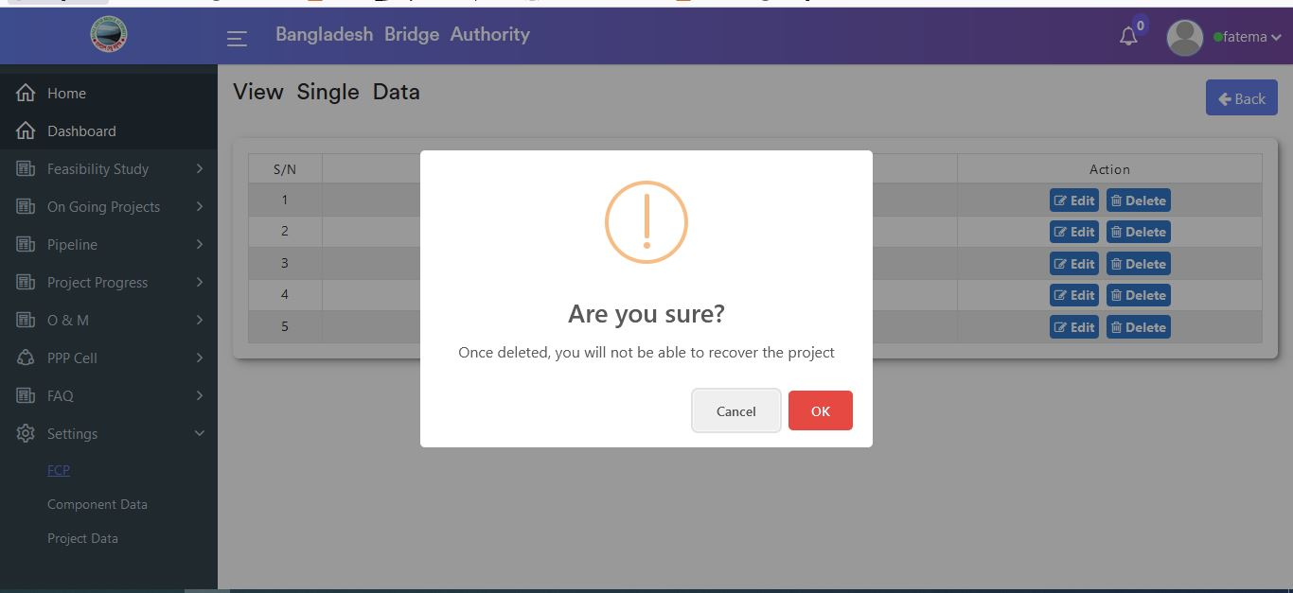

Figure 4.8.1.5: fcp (settings) view of fcp single data delete

### 4.8.2.1: Component Data(Settings) Add data input form

Click on the component data(settings) sub-menu by default component data table will display which is look like 1st scenario.Now Click on the Add data button after that component data input form will appear as like below 2nd scenario . User must fill up the required input fields with appropriate values to store component data record in the database.

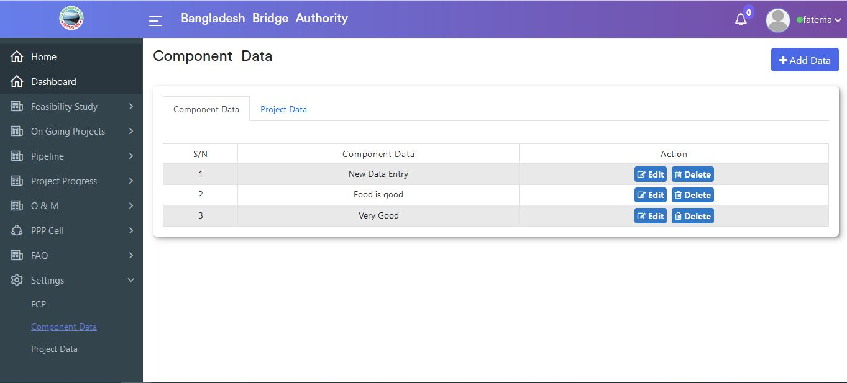

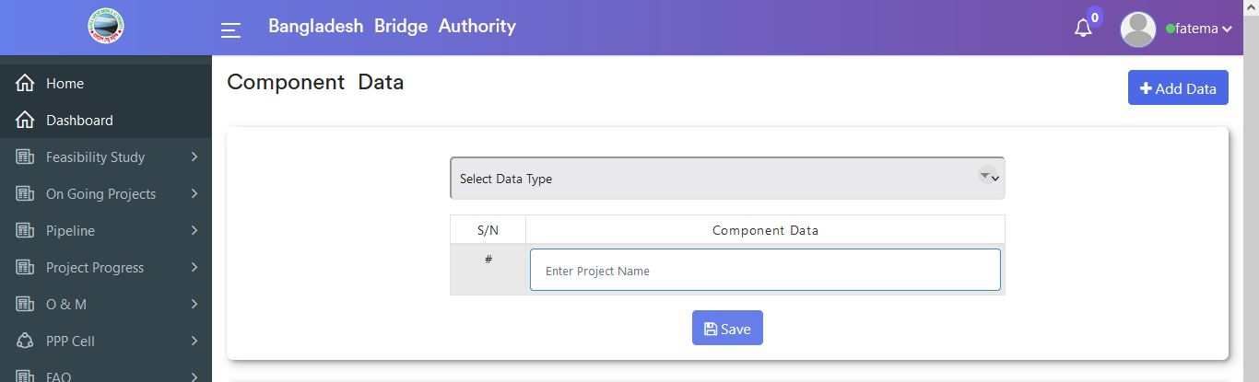

Figure 4.8.2.1: component data (settings) add data input form

### 4.8.2.2: Component Data(Settings) View of component and project data

Click on the component data(settings) sub-menu then by default component data table will display which is look like 1st scenario .Now Click on the Project data from the inline menu bar after that project data table will appear as like below the 2nd scenario .



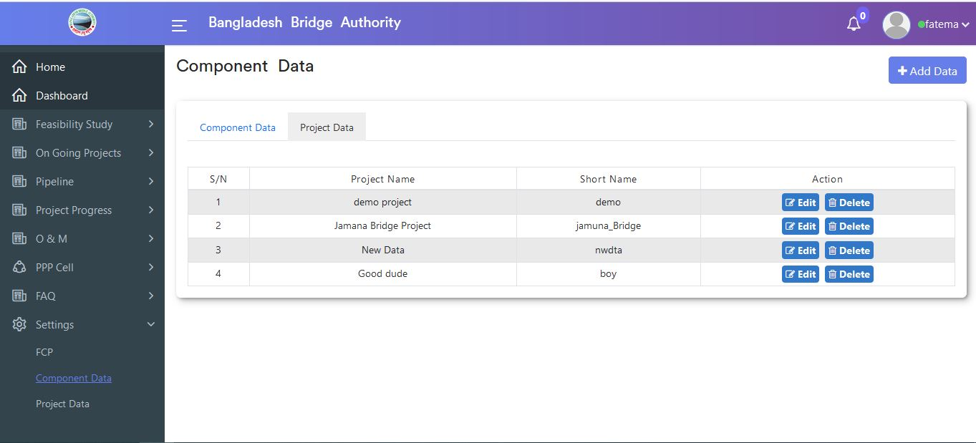

Figure 4.8.2.2: component data (settings) view component and project data

### 4.8.2.3: Component Data(Settings) component data edit

In Component Data (Settings) default data table if click on the edit button then pop-up modal input form will appear which is like the below scenario. User can change data as per as user required.

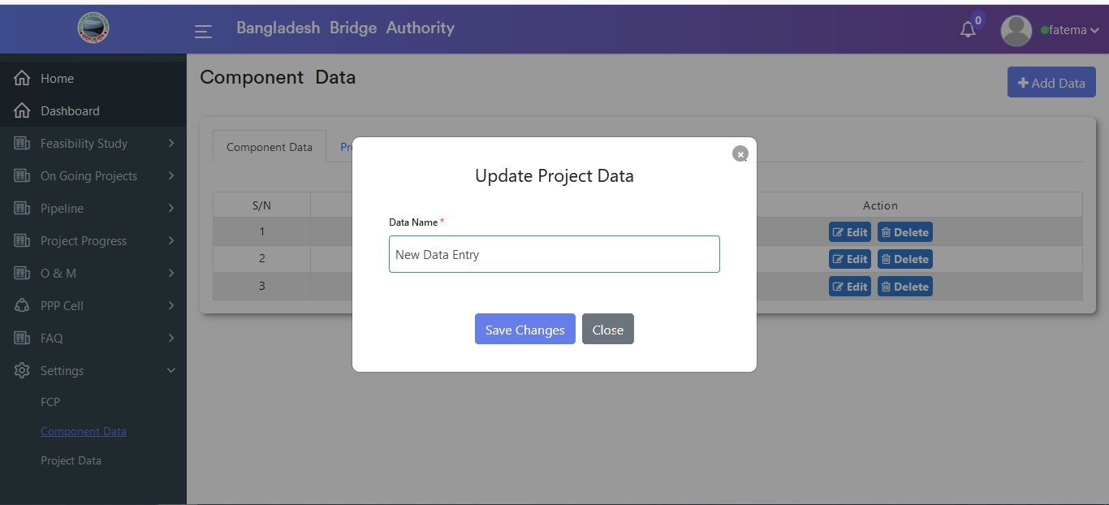

Figure 4.8.2.3: component data (settings) component data edit

#### 4.8.2.4: Component Data(Settings) component data delete

In Component Data (Settings) default data table if click on the delete button then looks like a pop-up modal will appear. If click ok on the pop-up modal then data will be deleted.

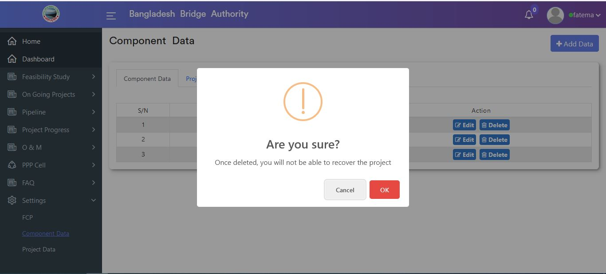

Figure 4.8.2.4: component data (settings) component data delete

### 4.8.2.5: Component Data(Settings) Project data edit

In Component Data (Settings) project data table if click on the edit button then pop-up modal input form will appear which is like the below scenario. User can change data as per as user required.

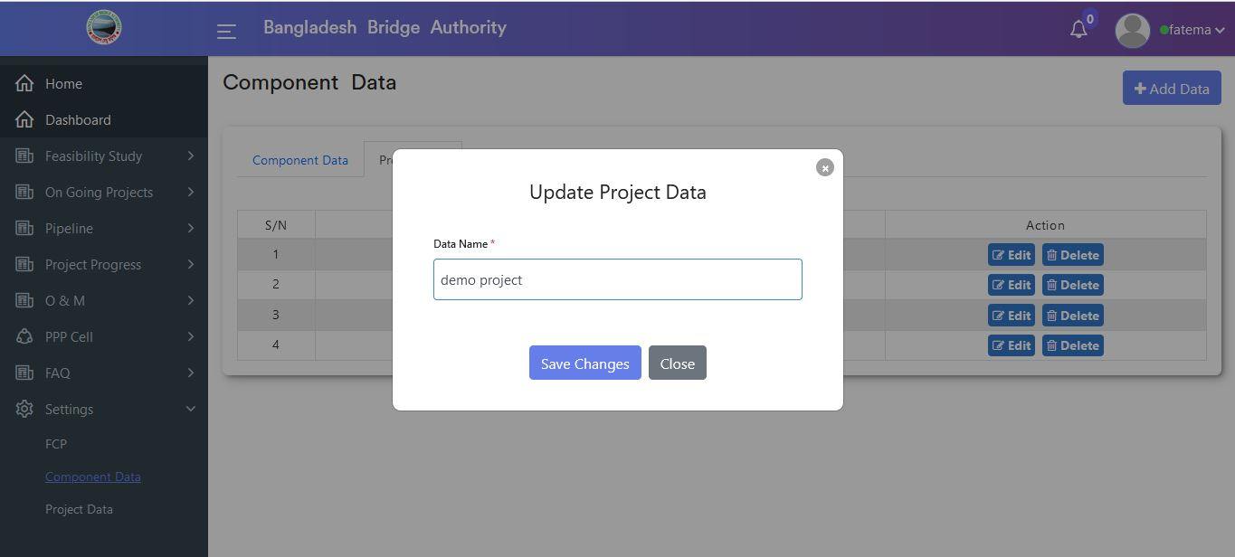

Figure 4.8.2.5: component data (settings) project data edit

### 4.8.2.6: Component Data(Settings) Project data delete

In Component Data (Settings) project data table if click on the delete button then looks like a pop-up modal will appear. If click ok on the pop-up modal then data will be deleted.



Figure 4.8.2.6: component data (settings) project data delete

### 4.8.3.1: Project Data(Settings) Add project data input form

Click on the Project data(settings) sub-menu by default project data table & Add option button will display which is look like 1st scenario .Now Click on the Add data button after that project data input form will appear as like below 2nd scenario . User must fill up the required input fields with appropriate values to store project data record in the database.

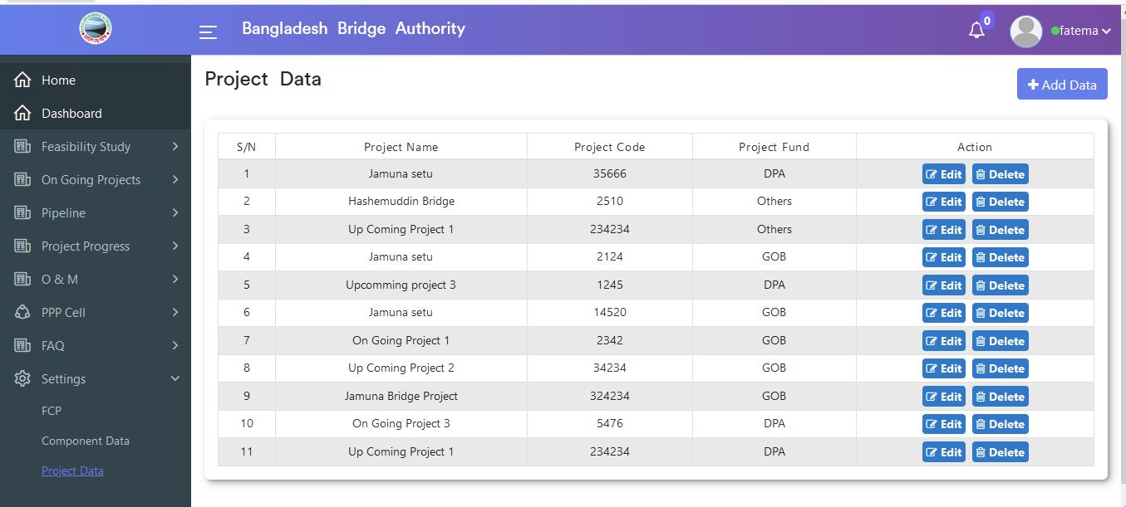

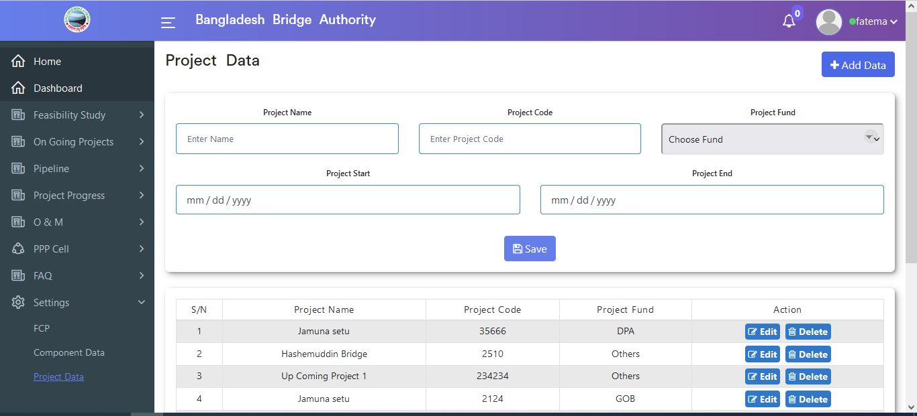

Figure 4.8.3.1: project data (settings) add project data input form

### 4.8.3.2: Project Data(Settings) project data edit

In Project Data (Settings) project data table if click on the edit button then pop-up modal input form will appear which is like the below scenario. User can change data as per as user required.

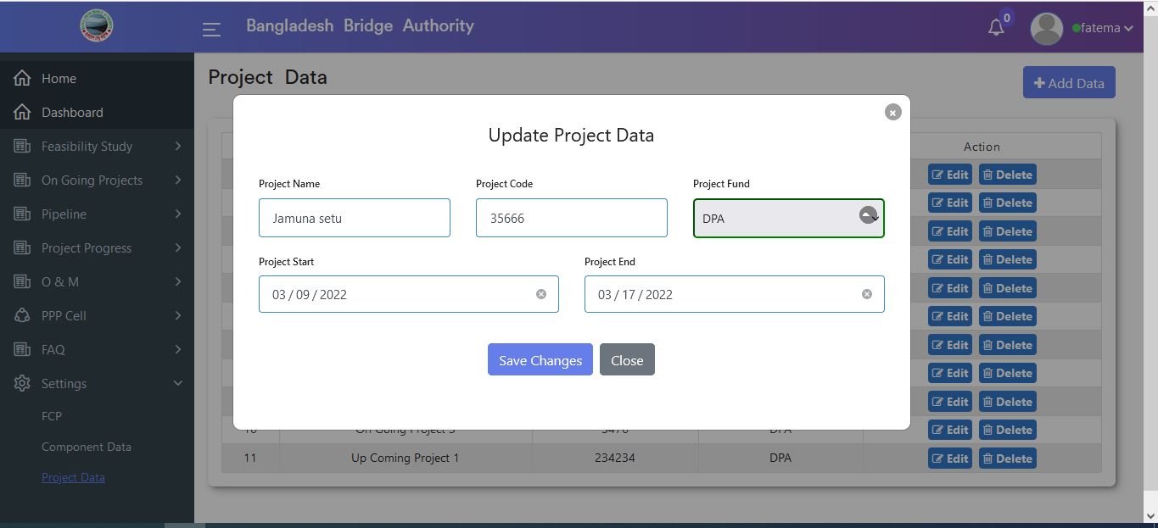

Figure 4.8.3.2: project data (settings) project data edit

### 4.8.3.3: Project Data(Settings) project data delete

In the Project Data (Settings) data table if click on the delete button then looks like a pop-up modal will appear. If click ok on the pop-up modal then data will be deleted.

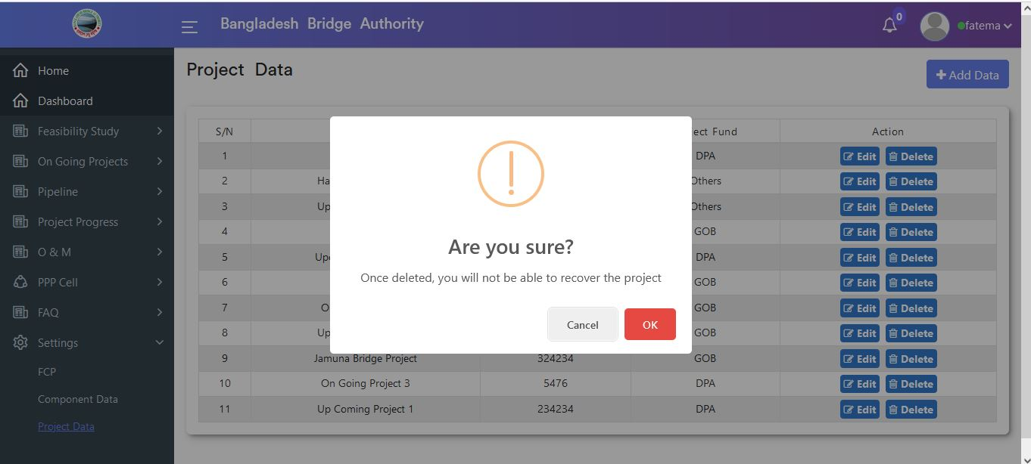

Figure 4.8.3.3: project data (settings) project data delete